

# School of InfoComm Technology

**Deep Learning Assignment**

Diploma in DS / IT

Oct 2023 Semester

**ASSIGNMENT 1**

(30% of DL Module)

**Submission Deadline:**

**Presentation: 10th Dec 2023 11:59PM**

**Report and Code: 10th Dec 2023 11:59PM**

|  |  |  |
| --- | --- | --- |
| **Tutorial Group** | **:** | **T01** |
| **Student Name** | **:** | Cheong Chun Fai |
| **Student Number** | **:** | S10243483 |

**Penalty for late submission:**

10% of the marks will be deducted every calendar day after the deadline.

**NO** submission will be accepted after 16th Dec 2022, 11:59PM.

Contents

1

[School of InfoComm Technology 1](https://d.docs.live.net/ab68988ac0965153/DS%20-%20Yr2/Semester%202/DL/ASG1/Assignment%201%20Report_Cheong%20Chun%20Fai.docx#_Toc153049656)

1 Overview 4

2 Data Preprocessing and Data Loading 6

3 Develop the Image Classification Model from Scratch 8

3.1 Model 1 - Baseline Model 9

3.2 Model 2 – Data Augmentation 11

3.3 Model 3 – Scaling Up 13

3.4 Model 4 – Scaling Up 14

3.5 Model 5 & 6 – Regulate with Dropout 15

3.6 Model 7 – Scaling Up 18

3.7 Model 8 – Scaling Up 20

3.8 Model 9 – Scaling Up + Dropout 21

3.9 Model 10 – Batch Normalization 23

3.10 Model 11 – Testing Padding 26

3.11 Model 12 to 17 – Learning Rate Tuning 27

3.12 Model 18 to 21 – Tuning Batch Size 30

3.13 Model 22 – Tuning Data Augmentation Transformer 32

3.14 Model 23 to 25 – Tuning Activation Function 34

3.15 Model 26 – Increase Kernel Size 39

3.16 Model 27 to 32 – Kernel Regularizer 40

3.17 Model 33 – Spatial Dropout 42

3.18 Model 34 – Train for 200 epochs 44

3.19 Model 35 – Final Model 45

3.20 Model 35 – Final Model 46

4 Develop the Image Classification Model with Pre-trained Models 47

4.1 Pre-trained 1 – Baseline 48

4.2 Pre-trained 2 – Fine Tuning (unfreeze 5th block) 49

4.3 Pre-trained 3 – Dropout 50

4.4 Pre-trained 4 – Fine Tuning (unfreeze 4th block) 52

4.5 Pre-trained 5 – Lowering Batch Size 54

4.6 Pre-trained 6 – Kernel Regularizer 56

4.7 Pre-trained 7 – Tuning Learning Rate 57

4.8 Pre-trained 8 - Fine Tuning (unfreeze 3rd block) 59

4.9 Pre-trained 9 – Tuning Learning Rate 60

4.10 Pre-trained 10 – Training for more epoch 61

5 Evaluate models using Test Images 62

6 Use the Best Model to perform classification 63

7 Summary 66

8 References 67

9 Appendix 68

# Overview

The task at hand is to build a neural network model to tackle classification of 10 distinct types of food items.

The 10 distinct types of food items:

1. Breakfast burrito
2. Croque madame
3. Fried rice
4. Hot dog
5. Huevos rancheros
6. Pad thai
7. Risotto
8. Samosa
9. Spaghetti Bolognese
10. Strawberry shortcake

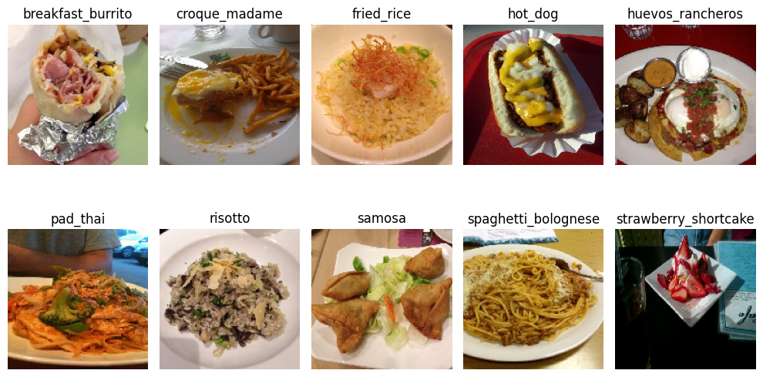

[Image of each food type picked at random from the whole dataset]

Primary objective of this assignment is to develop an effective image classification model capable of accurately categorizing these specific food types stated above. The evaluation of the model performance will be primarily based on the standard metrics of accuracy score, paired along with loss values. These standard metrics will assist me in quantifying the models’ classification capabilities.

Such food image classification models are normally used to perform accurate identification and categorization of food hold substantial significance across various domains, from nutritional analysis and dietary recommendations to recipe recommendations systems and culinary research. One case scenario where this type of model may come in handy would be in mobile applications that assist users in tracking their nutrition intake. With a simple snapshot of the food, the model will try and identify the food type and generate nutrition statistics such as calories, fat in grams, saturated in grams, etc. However, this is to simply assist user in efficiently tracking their nutritional intake. A possibility of wrong classification of food that led to inaccurate tracking of nutritional intake is not zero.

Our approach of data preprocessing for this assignment involves data splitting (using the Image_Preprocessing.ipynb given) to form distinct training, validation, and test sets of different proportions.

For model development, we plan to proceed with two different strategies. The first approach involves constructing a model from scratch utilizing primarily convolutional and dense layers. Moving on to the second approach we aim to leverage transfer learning by employing pre-trained models, benefiting from their learnt features for enhanced classification performance.

Inspired by the suggested universal machine learning workflow to develop the model and improve the model performance stated in the assignment brief, in order for us to ensure optimal model performance, we intend to firstly start off with a baseline model, leading to iteration on model architectures, gradually scaling their complexity while addressing potential issues like overfitting through regularization techniques. Furthermore, hyperparameter tuning will be a key aspect of our methodology, aiming to fine-tune model parameters to achieve classification results with higher quality. [back]

During the model building and training process, we anticipate that comparing the performance of these models will offer insights into their accuracy, generalization capacity, and computational efficiency. However, there come some challenges that can be anticipated such as the constraint on computational resource to efficiently train complex models that may be out of our reach but may produce far better predictions and potential model overfitting. Therefore, during the model development process, we aim to address these challenges by employing scalable solutions (optimizing memory usage of computer, taking minor steps in testing optimal hyperparameter configuration instead of testing in parallel) and employing regularization techniques.

Since model development involves a long process of making changes to the characteristics of the model, some hyperparameter will take a longer time to tune due to the sensitivity of the strength and the impact it can make on the performance of the model.

The determination of which model performance is better and how should we proceed with further tune hyperparameter with a goal to improve quality of the model will be based on performance metrics of mainly accuracy, loss, validation accuracy and validation loss, and supported with visual representation of these metrics using curves.

By utilizing the test images that were split from initial dataset, we will evaluate the model performance of all the models we’ve built so far for BOTH approaches and determine which of the pool of models performed the best on the test images. Lastly, we will use at least one image of each of the food type mentioned, source from the internet acting as unseen data, and finally use the determined best model to predict which food class does it belong to.

Note: Assignment was conducted using tensorflow-gpu, specific GPU is GeForce RTX 2070 Super. However, even though I am running on GPU, there were some hyperparameter tested that led to higher usage of GPU and memory, and at times, Jupyter Notebook run into memory error where there is not enough memory to allocate to the epoch training. Hence, that too limited my options of experimenting more advanced hyperparameter that can potentially improve model performance.

# Data Preprocessing and Data Loading

The Food-101 dataset that we were instructed to download consists of 101 different food type and for each of them, there is 1000 images.

Using the “Image_Preprocessing.ipynb” given, we were able to not only retrieve subsets of our assigned food type but also split the 1000 images of each food type into train, validation, and test folders. The subset ratio of train:validation:test is 0.75:0.2:0.05. In other words, there will be 750 images in training, 200 images in validation and 50 in test folder for each food types. After running the code in “Image_Preprocessing.ipynb”, three new folders named “train”, “validation” and “test” were created with folders of the 10 food types and in each food type there is 750, 200 and 50 images respectively for “train”, “validation” and “test” folder.

When given a foreign dataset, a good practice is to perform Exploratory Data Analysis, regardless of the type of data. Since we’re working with images as data here, an ideal approach to understanding the data we’re given would be to have a quick glance of the images provided in File Explorer by changing the view setting.

After exploring the data, here are some “outliers” I would identify.



The label of this image above is a “hot_dog” under the hot_dog folder in train.

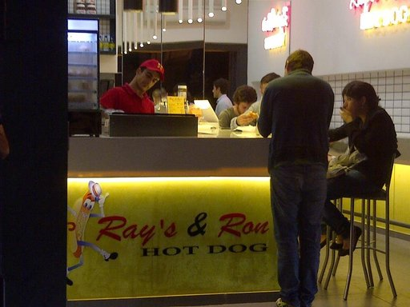

The label of this image above is too, a “hot_dog”.

This provided me with an understanding that the images provided may not directly correspond to the label of that image itself. Moreover, because the images above are just a subset of potential “outliers” in the hot_dog folder under train, I must consider other “outliers” of other food type in not only the train folder but the validation and testing folder too.

In other words, these “outliers” can bring in noisy data which will affect the performance of my model if not dealt with accordingly with methods such as increasing complexity of model, introducing data augmentation to bring in more robust features of images, etc.

Moving on to our approach on the code, we will be using local Jupyter Notebook environment to run our assignment notebook. For the data loading portion, we first set up a variable storing the base directory of where the data are stored. Not only that, when we are saving the models we’ve developed, we will also save the H5 files in the same base_dir we have declared. Next, we will create three new directory variable which are for train, validation, and test respectively.

For initial data preprocessing, we will be setting up image data generators using the ‘ImageDataGenerator’ class in the Keras under Tensorflow. The image size we will be using to rescale out images will be 150 x 150 input dimension as recommended in the assignment brief. With the help of directory variables declared previously, image data are put into the ImageDataGenerator where rescaling of image will take place. Using “rescale=1./255”, the ImageDataGenerator will normalize the pixel values of the images. By dividing all pixel values by 255, it scales them to a range between 0 and 1. This step of rescaling is crucial because it will help during the model training, as it makes the model more stable and aids in faster convergence.

Throughout the model development process for this assignment, a further data preprocessing step will take place. Image data will be augmented with ImageDataGenerator to artificially expand the dataset by applying various transformation to the existing images, thus helping improve the generalization and robustness of the model. These transformations include, rotation, left-right and up-down shifting, shearing, and zooming of images, and horizontal flipping of the image.

For models that were built from scratch, image size was 150 x 150 throughout. However, I have once considered using image size such as 224 x 224 or 256 x 256 because majority of the prominent neural network models in Computer Vision and Image Processing fields use these image sizes. [1] (to validate this claim by the user who replied to the blog, I did some research on existing CNN models under Keras and this claim is valid, there are indeed pre-trained models that uses 224 x 224 input size [2])The one and only reason why this was not applied for scratch model was because of the increase usage of computer hardware and the time taken to train a model will increase as well. To try and maximise number of hyperparameter testing, a rough gauge of how long one model takes to train is a crucial factor to take into consideration.

For models that were built using transfer learning of pre-trained model, image size was 224 x 224 throughout. This will be further explained at the later part of the report where the selection of pre-trained model is mentioned.

# Develop the Image Classification Model from Scratch

Architecture and characteristics of other hyperparameter of the model will be represented in a vertical table format.

Since the order of layers in architecture is as follows:

|  |
| --- |
| Architecture |
| Input Conv2D |
| Hidden Layers |
| ~~Flatten~~ |
| Dense; Fully Connected Layers |
| Output Dense of 10 units |

**Important:**

The table will exclude Flatten to save space in the report. Model summary is called in the Jupyter notebook for every model hence do refer to the model if required. Moreover, for each architecture table of each model, the cell representing changes made from previous model will be highlighted yellow. This is YELLOW.

Do note, filter size is (3, 3) throughout unless specified it was tuned and image size is 150 x 150.

Do also note, there is no specific framework that was followed on what changes to make after each model. The choices were mainly inspired by the universal workflow [ref] suggested in the assignment brief.

If I were to provide a general framework, it would be:

Baseline 🡪 Data Aug 🡪 Scale up 🡪 Regulate if overfit 🡪 Repeat scaling up and regularization till satisfied 🡪 Tuning hyperparameters.

|  |
| --- |
| Other Hyperparameters |
| Optimizer: Adam |
| Learning Rate: 1e-4 / 0.0001 |
| Batch size: 32 |
| Epoch: 50 |

## Model 1 - Baseline Model

|  |
| --- |
| Architecture |
| Input 32, relu + MaxPooling 2 |
| Conv2D 32, relu + MaxPooling 2 |
| Output 10, Softmax |

A baseline model should be simple. Hence it will lack complexity and may have little predictive power. It will act as a benchmark to models trained afterwards. [3]

The model architecture is rather simple, this level of simplicity can help me establish a basic understanding of how my model performs before moving to making changes to the architecture or the hyperparameters.

**Optimizer:**

Popular optimizers in deep learning includes SGD (Stochastic Gradient Descent), adaptive gradient methods such as AdaGrad (**Ada**ptive **Grad**ient algorithm) and Adam (**Ada**ptive **M**oment Estimation). [4]

So why did I pick Adam optimizer? To understand, we must first mention some technical concepts that led to my decision of Adam optimizer. However, since it involves a lot of technical terms and may not be relevant to be placed at this point of the report, I will be placing it in the Appendix. [Appendix A]

To sum everything up in the Appendix, Adam optimizer is awesome because it takes the best parts of two other methods: Momentum and RMSprop. Adam adjusts how fast it learns and also the direction it moves in. Hence, I chose Adam optimizer as it is like an all-in-one optimizer.

**Learning Rate:**

The default learning rate of Adam is 1e-3 / 0.001. I use a lower learning rate of 1e-4 / 0.0001 to allow a more cautious and stable training process to happen, which is beneficial when dealing with noisy datasets (assumed in data exploration under “Data Preprocessing and Data Loading”).

This adjustment will help with model better adapt to the noisy characteristics of the data, resulting in more reliable and robust training.

**Batch Size:**

“Usually, we chose the batch size as a power of two, in the range between 16 and 512. But generally, the size of 32 is a rule of thumb and a good initial choice.” [8]

Number of Param: 424,874

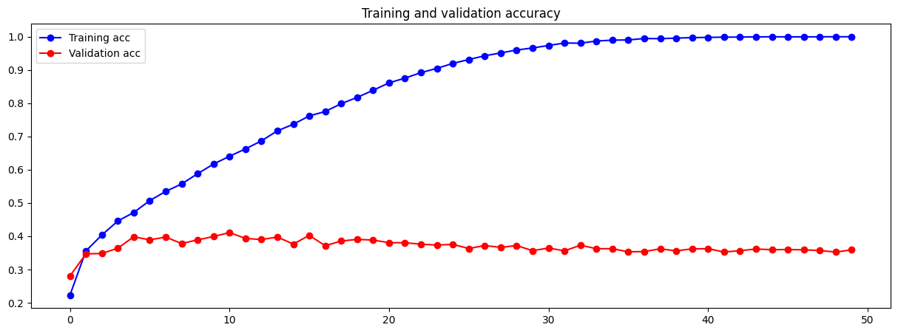

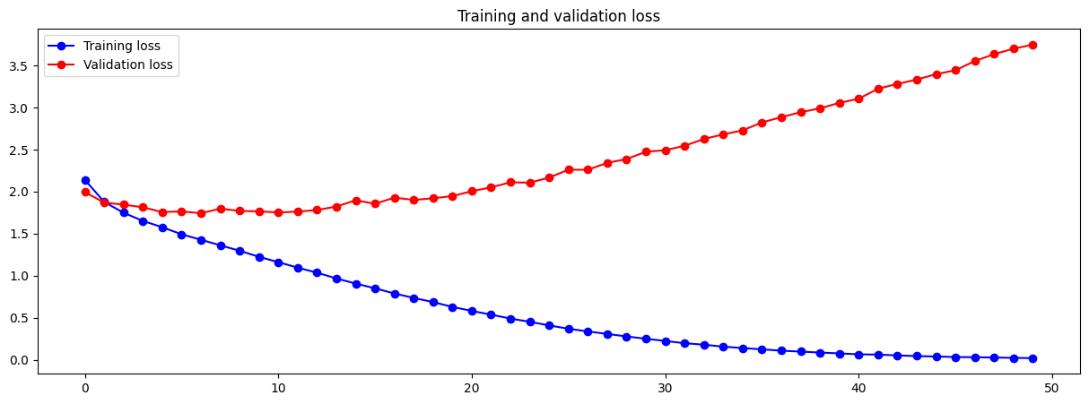

The loss curve of the baseline model shows a clear indication of validation loss being significantly larger than the training loss, hence model is overfitting. The significant gap between training and validation losses indicates that the model is not effectively generalizing the learnt patterns to new instances / unseen data.

The training accuracy reached 100% at epoch 49/50 while the validation accuracy sits at around 36% since epoch 4, a difference of 64%.

Since there is a clear indication of overfitting being present, we will move straight to try and regulate the model first.

## Model 2 – Data Augmentation

Architecture and hyperparameter configuration remained the same as baseline.

Taught in Lecture 3 regarding Overfitting and Underfitting, the best solution to deal with overfitting models is to simply get more training data. However, to align with the instructions given to use data from Kaggle, I do not wish to arbitraryly input my own data or mess with the data given.

Data augmentation,

1. Increases the “volume” of data:
   * Artificially increase the dataset’s size by generating modified versions of existing data.
2. Introduces diversity:
   * Applying transformation parameters available in ImageDataGenerator such as rotations, flips, zooms, shifts, and other modifications to the existing data, we are essentially creating new instances that differ in appearance from the original image.
   * Hence, introduce diversity in the dataset, introducing a broader range of visual scenarios and variations to the model.
3. Generalization improvement:
   * By simply “increasing” the dataset’s size, and training on a more diverse dataset, the model learns to generalize better, meaning it can make accurate predictions on unseen data that might exhibit different characteristics from the training set.

Thus, the choice of using Data Augmentation. [7]

Data augmentation setting:

* Rotation range of 40
* Width shift range (left-right) of 0.2
* Height shift range (up-down) of 0.2
* Shear range of 0.2
* Zoom range of 0.2
* Horizontal flipping

This setting was inspired by data augmentation configuration provided in previous practicals.

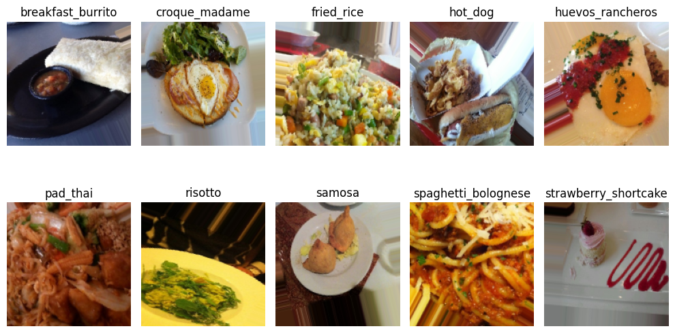

[Image of each food type picked at random from the whole dataset after Data Augmentation]

Number of Param: 424,874

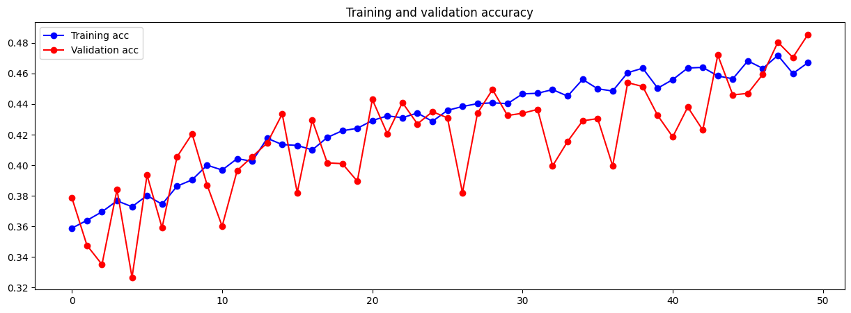

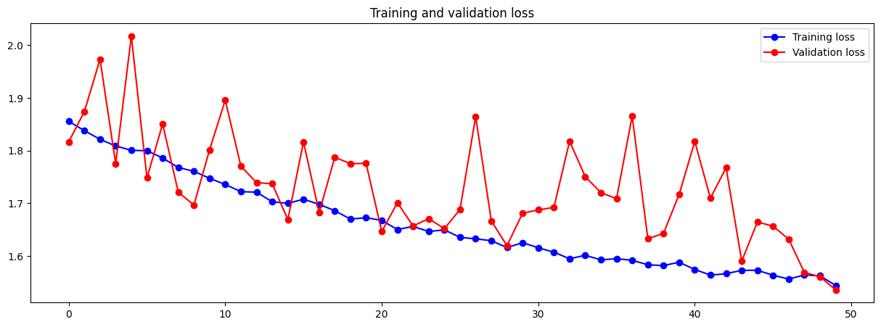

A clear observation of vigorous fluctuations can be seen in both the accuracy and loss chart. The main reason for this is because, since data augmentation introduce more variation of data into the training process, there is a stricter need for the model to learn to accommodate and adapt to augmented variability.

As seen, with implementation of data augmentation, it has effectively combat overfitting by diversifying the training data. At epoch 48 where training and validation accuracies were closest to one another, the training accuracy peaked at 47% while for validation accuracy, it was 48%. At epoch 50, both training and validation set met at a similar loss of around 1.53.

Since overfitting has been tackled with for now, I proceeded to follow the universal workflow of scaling up and regularizing the model from this point on.

## Model 3 – Scaling Up

Scaling up a model by adding more layers or units aims to enhance its ability to learn intricate data patterns by increasing the complexity of the model itself, potentially improving accuracy. However, this increased complexity raises the risk of overfitting once again. Thus, regularization techniques like dropout will also be tested in the process to promote robust learning of generalizable features.

In conclusion, the process of scaling up and regularizing the model come hand in hand.

|  |
| --- |
| Architecture |
| Input 32, relu + MaxPooling 2 |
| Conv2D 64, relu + MaxPooling 2 |
| Conv2D 128, relu + MaxPooling 2 |
| Conv2D 256, relu + MaxPooling 2 |
| Dense 256, relu |
| Output 10, Softmax |

|  |
| --- |
| Other Hyperparameters |
| Optimizer: Adam |
| Learning Rate: 1e-4 / 0.0001 |
| Batch size: 32 |
| Epoch: 100 |

Number of Param: 3,602,506

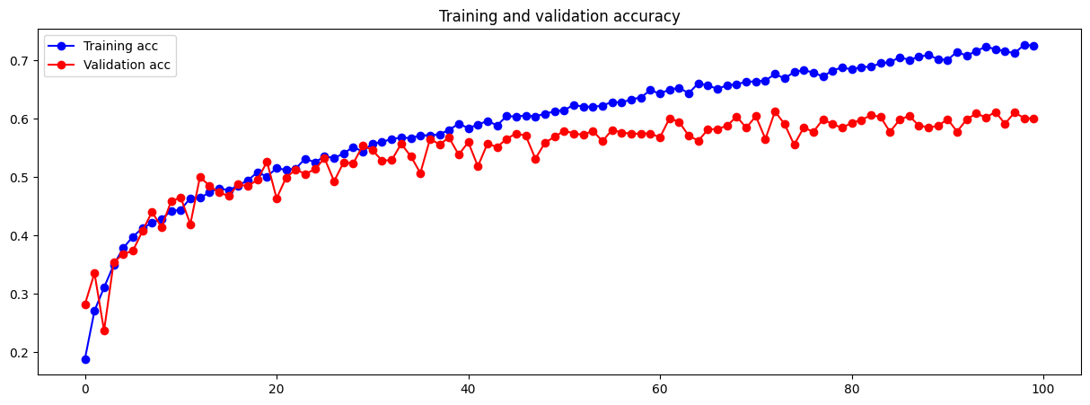

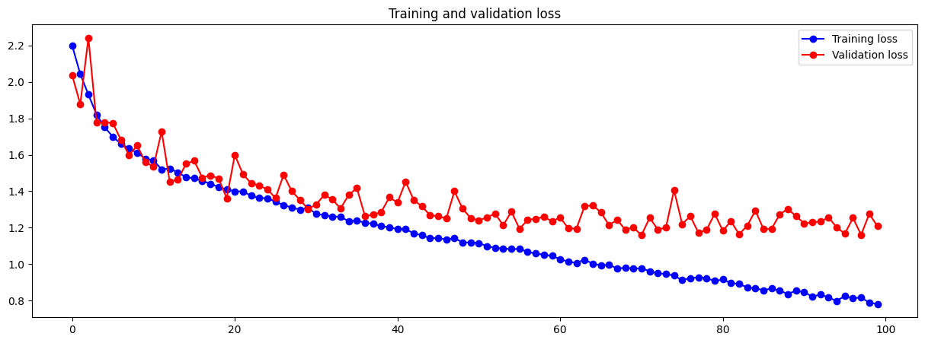

Do note this model has been trained for 100 epochs instead of 50, hence the visual representation that shows the fluctuation is not as drastic as before. However, the fluctuation rate can be assumed to have dropped as increase in model complexity do stabilize fluctuations of performance metrics by allowing the model to extract complex features for better understanding.

Reason for the increase of epoch is that since the complexity of model is higher, there are more parameters to be trained and can be assumed that the model will take a longer time to converge.

From these charts, it can be seen that the training and validation accuracy has already surpassed the previously best from epoch 14 onwards. Training accuracy reached a new high of roughly 72% while for validation accuracy it is 60%. At around epoch 36, the training and accuracy loss starts to diverge but there is no clear indication of overfitting even at the 100th epoch. More epochs are to be trained to view the occurrence of overfitting.

Which then gave me the idea to scale up even more.

## Model 4 – Scaling Up

|  |
| --- |
| Architecture |
| Input 32, relu + MaxPooling 2 |
| Conv2D 64, relu + MaxPooling 2 |
| Conv2D 128, relu |
| Conv2D 128, relu + MaxPooling 2 |
| Conv2D 256, relu |
| Conv2D 256, relu + MaxPooling 2 |
| Dense 256, relu |
| Output 10, Softmax |

|  |
| --- |
| Other Hyperparameters |
| Optimizer: Adam |
| Learning Rate: 1e-4 / 0.0001 |
| Batch size: 32 |
| Epoch: 100 |

Number of Param: 3,488,202

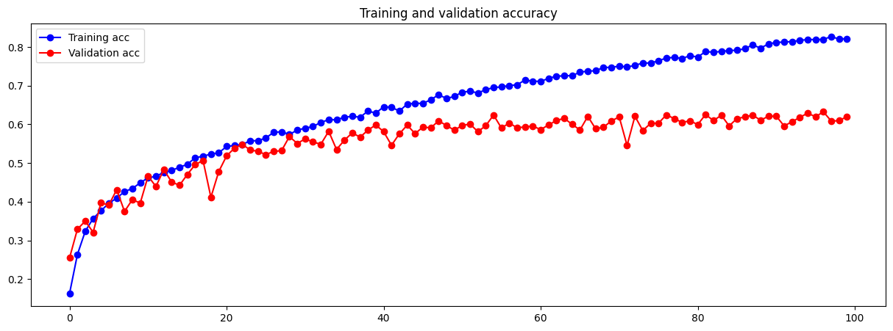

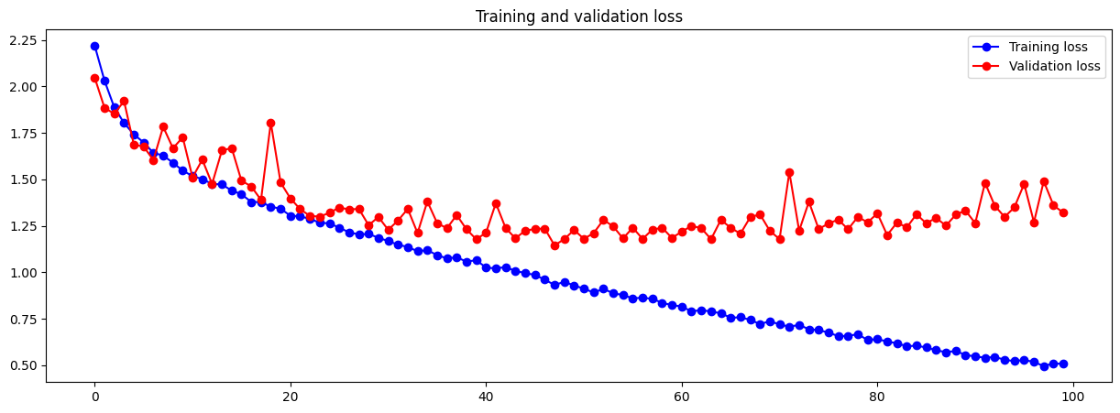

Complexity of the model has been increased yet again. Now we can see that the y axis limit has increased from 0.7 to 0.8 and it can also be seen that training accuracy has again reached a new high of 82% compared to the previous 72%. However, for validation accuracy, it has been quite stagnant at around 62%, only an increase of 2% from the previous model.

Moreover, the divergence of training and validation loss occurs at a slightly earlier epoch of around 30 now. There is a clear indication of overfitting now compared to the previous model as the validation loss chart is starting to “smile” back at us.

Hence, a need for regularization techniques to be deployed.

## Model 5 & 6 – Regulate with Dropout

Dropout is a regularization technique used to prevent overfitting in neural networks. It works by randomly “removing”/muting/freezing individual neurons or connections during training, forcing the network to learn more robust and generalized features, hence preventing individual neurons from becoming overly reliant on specific features or correlations in the data, forcing other neurons to be learnt in the training.

With the presence of dropout, in each iteration, some units on the layer would be randomly “removed” (dependent on dropout strength), thus lesser neurons are active in the forward propagation process, leading to the overall structure of neural network being simplified. [8]

Strength declared is represented as a decimal value between 0 and 1, where 0.5 would imply a 50% probability of dropping a neuron.

**Model 5, dropout strength of 0.3**

|  |
| --- |
| Architecture |
| Input 32, relu + MaxPooling 2 |
| Conv2D 64, relu + MaxPooling 2 |
| Conv2D 128, relu |
| Conv2D 128, relu + MaxPooling 2 |
| Conv2D 256, relu |
| Conv2D 256, relu + MaxPooling 2 |
| Dense 256, relu |
| Dropout, 0.3 |
| Output 10, Softmax |

|  |
| --- |
| Other Hyperparameters |
| Optimizer: Adam |
| Learning Rate: 1e-4 / 0.0001 |
| Batch size: 32 |
| Epoch: 100 |

Number of Param: 3,408,202

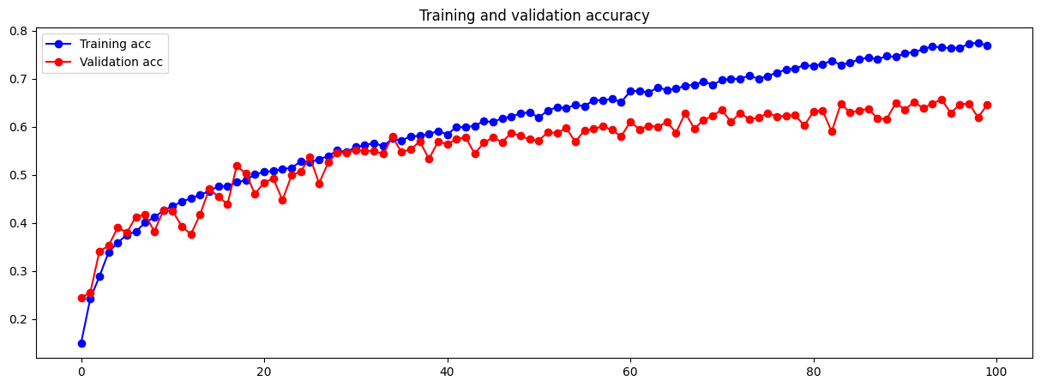

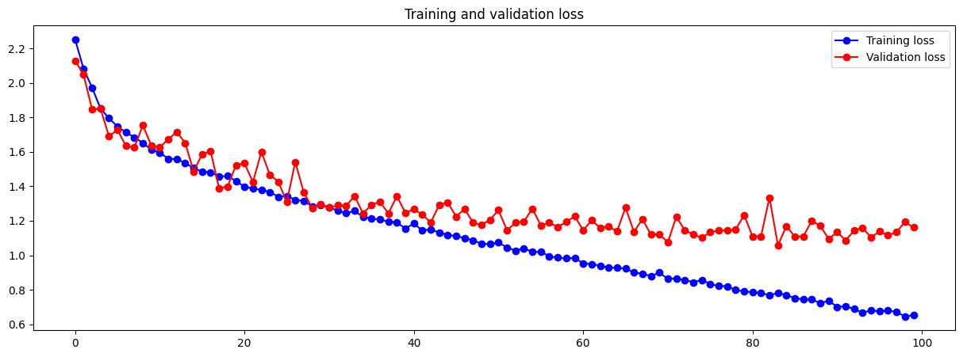

Addition of dropout layer after the dense layer did regulate the model and the magnitude of overfitting is not as high or in fact it cannot be seen clearly, more epochs will need to be trained to conclude overfitting exist for this model.

Now, the divergence of training and validation loss occurs at a more later epoch of around 43. There is also an improvement in the validation accuracy, it has reached a new high of roughly 64%, an increase of 62% from previous model.

Since there is a potential overfit of model occurring if we were to train for more epoch and in consideration of how the strength of dropout, 0.3 (implied as 30% probability), is not too aggressive yet, I’ve decided to try a dropout strength of 0.5 (implied as 50% probability).

**Model 6, dropout strength of 0.5**

|  |
| --- |
| Architecture |
| Input 32, relu + MaxPooling 2 |
| Conv2D 64, relu + MaxPooling 2 |
| Conv2D 128, relu |
| Conv2D 128, relu + MaxPooling 2 |
| Conv2D 256, relu |
| Conv2D 256, relu + MaxPooling 2 |
| Dense 256, relu |
| Dropout, 0.5 |
| Output 10, Softmax |

|  |
| --- |
| Other Hyperparameters |
| Optimizer: Adam |
| Learning Rate: 1e-4 / 0.0001 |
| Batch size: 32 |
| Epoch: 100 |

Number of Param: 3,408,202

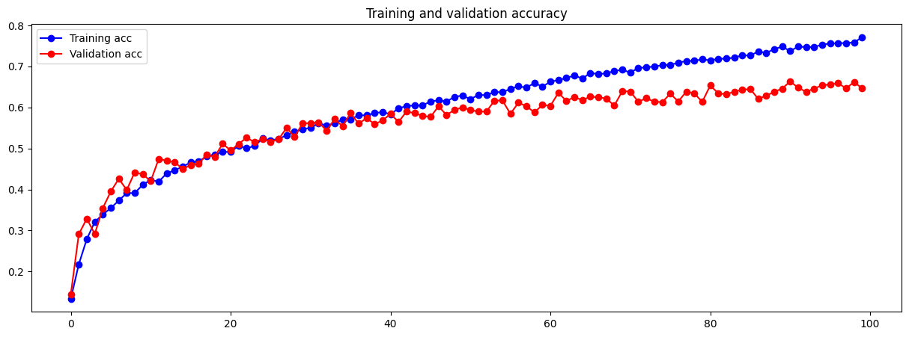

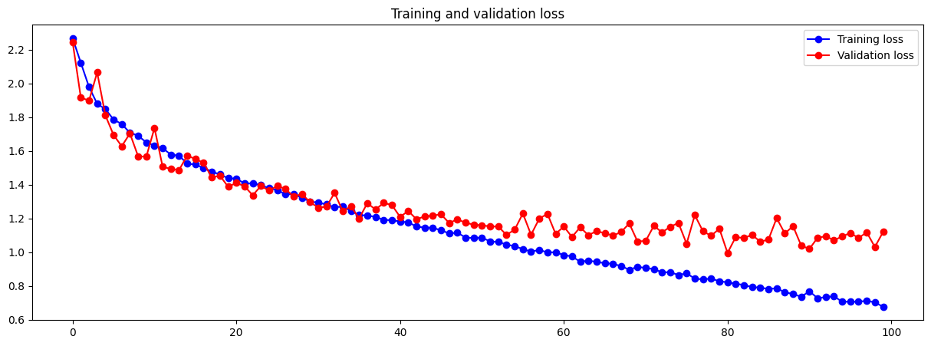

Now the probability of “removing” a neuron in the dense layer is 50%. The magnitude of overfitting has again been further decreased, which is a good sign. Divergence of training and validation loss now occurs at around epoch 52. Moreover, it has also mitigated overfitting from occurring in this model of 100 epochs.

Validation accuracy has yet been increased slightly, hovering at around 65%.

Decided to proceed with Model 6, dropout strength of 0.5 as it encourages a greater robustness of feature learning and ensuring that the model can still effectively learn important patterns from the data. Since magnitude of overfitting has been reduced greatly, I tried to scale up once again to increase model complexity.

## Model 7 – Scaling Up

|  |
| --- |
| Architecture |
| Input 32, relu |
| Conv2D 32, relu + MaxPooling 2 |
| Conv2D 64, relu |
| Conv2D 64, relu + MaxPooling 2 |
| Conv2D 128, relu |
| Conv2D 128, relu + MaxPooling 2 |
| Conv2D 256, relu |
| Conv2D 256, relu + MaxPooling 2 |
| Dense 256, relu |
| Dropout, 0.5 |
| Output 10, Softmax |

|  |
| --- |
| Other Hyperparameters |
| Optimizer: Adam |
| Learning Rate: 1e-4 / 0.0001 |
| Batch size: 32 |
| Epoch: 100 |

Number of Param: 2,813,482

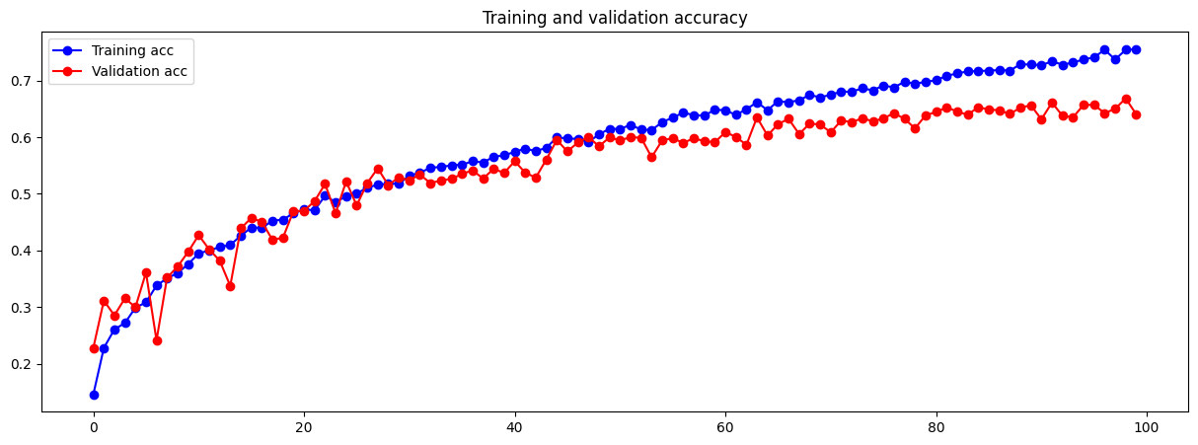

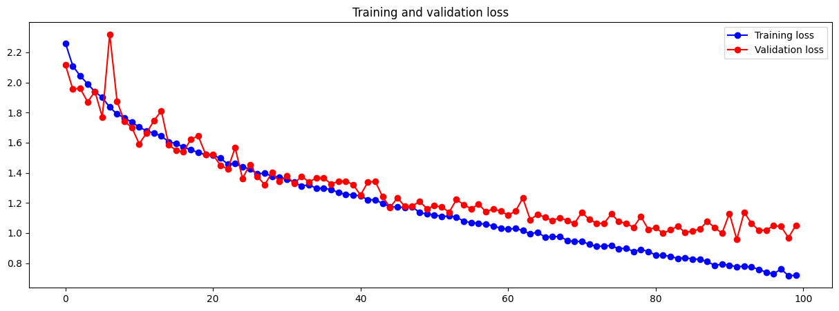

Complexity of model have once again been increased. Although the divergence of training and validation loss still starts at around the 52nd epoch, the rate of divergence has been decreased as seen from the gap of both lines smaller than the previous model. The increase in model complexity made the model less biased towards specific examples and the increase in effectiveness of feature extraction contributed to better generalization, thereby potentially reducing the divergence between training and validation loss, as seen above.

Though a decrease in training accuracy, it is a good sign as it suggests that the model is performing similarly well on both training and validation (i.e. unseen) data. The highest validation accuracy here is estimated to be 67%.

With this, I’ve decided to increase the complexity of the model once again by scaling up in hope of achieving a new high for validation accuracy.

## Model 8 – Scaling Up

|  |
| --- |
| Architecture |
| Input 64, relu |
| Conv2D 64, relu + MaxPooling 2 |
| Conv2D 128, relu |
| Conv2D 129, relu + MaxPooling 2 |
| Conv2D 256, relu |
| Conv2D 256, relu + MaxPooling 2 |
| Conv2D 512, relu |
| Conv2D 512, relu + MaxPooling 2 |
| Dense 256, relu |
| Dropout, 0.5 |
| Output 10, Softmax |

|  |
| --- |
| Other Hyperparameters |
| Optimizer: Adam |
| Learning Rate: 1e-4 / 0.0001 |
| Batch size: 32 |
| Epoch: 100 |

I have decided to double the number of filters in each convolutional layers instead of adding more layers to increase model complexity, providing the model with more opportunities to extract various features from the data.

This expanded feature space enables the model to learn a broader range of patterns, potentially improving its understanding of the underlying data.

Number of Param: 7,965,002

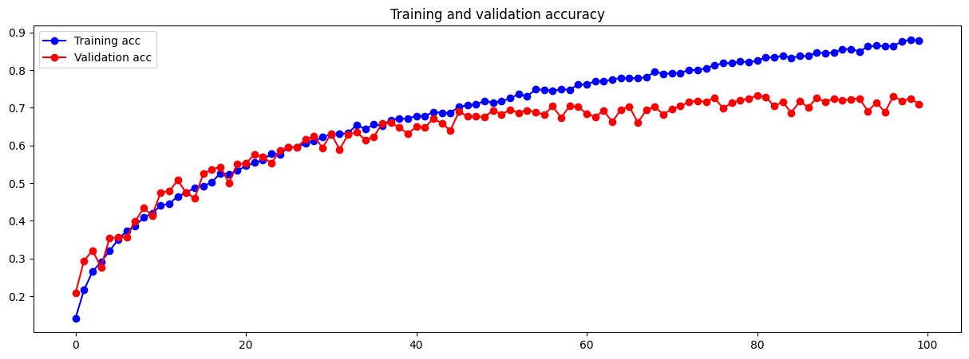

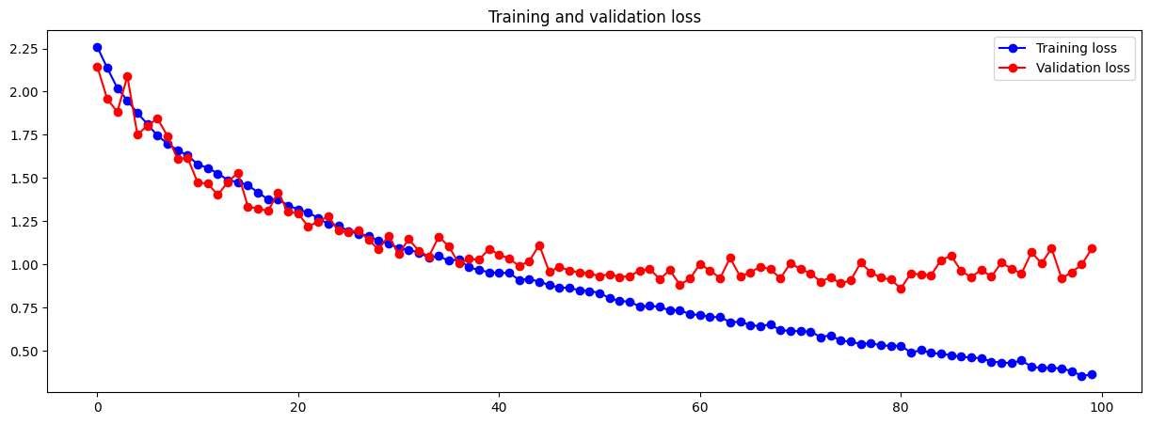

This increase in model complexity surely did improve the training accuracy significantly again with the y axis limit being 0.9. However, overfitting is seen once again as the model is “smiling” back at us. Thus, regularization techniques will have to take place after this model. The epoch where divergence starts has also been shifted forward, where model starts diverging at around the 47th epoch.

On the bright side, the increase in complexity did achieve a new high of validation accuracy at roughly 71%.

## Model 9 – Scaling Up + Dropout

Scaling up to increase the model complexity and using dropout regularization has both shown effect on dealing with overfitting models respectively. This then made me curious whether adding both at once will still take effect and tackle overfitting models.

|  |
| --- |
| Architecture |
| Input 64, relu |
| Conv2D 64, relu + MaxPooling 2 |
| Conv2D 128, relu |
| Conv2D 128, relu + MaxPooling 2 |
| Conv2D 256, relu |
| Conv2D 256, relu + MaxPooling 2 |
| Conv2D 512, relu |
| Conv2D 512, relu + MaxPooling 2 |
| Dense 256, relu |
| Dropout, 0.5 |
| Dense 256, relu |
| Dropout, 0.5 |
| Output 10, Softmax |

|  |
| --- |
| Other Hyperparameters |
| Optimizer: Adam |
| Learning Rate: 1e-4 / 0.0001 |
| Batch size: 32 |
| Epoch: 100 |

Number of Params: 8,030,794

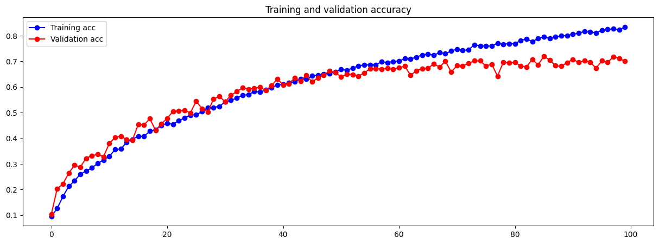

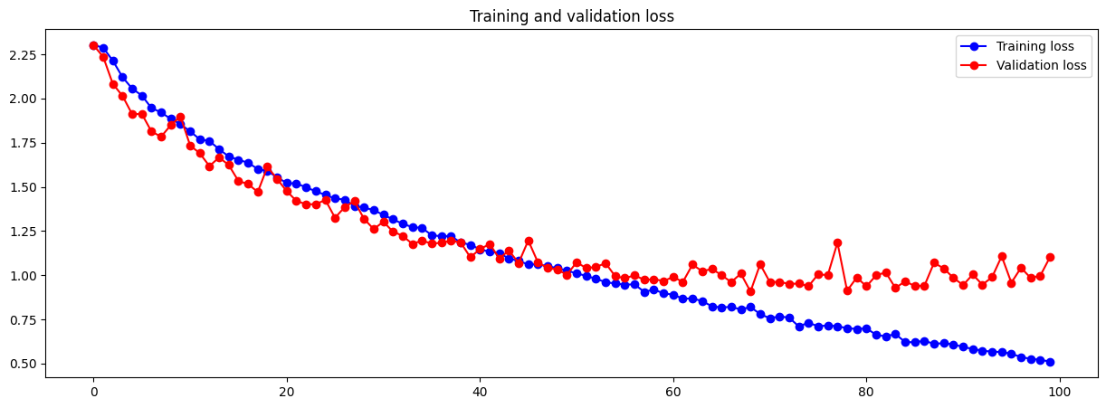

This increase in model complexity has yet again reduced the magnitude of overfitting, where overfitting takes place much slower though divergence starts at around the same epoch. More epoch training will be required to determine overfitting of model.

The training accuracy has been brought closer to the validation accuracy once again, with validation accuracy being stable at 70%.

At this stage, I felt that there was enough scaling up done to the model (at least for this assignment and assignment period), hence I’ve decided to now explore the possibility of optimizations and tuning hyperparameter. That’s when a new concept that I was introduced to during week 6 LinkedIn Learning came into my mind, which is Batch Normalization.

## Model 10 – Batch Normalization

Batch Normalization tackles the challenge of a phenomenon called “internal covariate shift”. This challenge happens during the training process of model, meaning the direction would be forward propagation. During each instance of back propagation, the model learns and updates its weights every time, hence the distribution of inputs to each layer can shift. This will reduce the efficiency of model learning the data well enough to produce a higher quality model. The shift in weights make it such that it will be more challenging for the model to keep adapting to the changing distribution, slowing down the process of training and affecting the potential of achieving higher performing models.

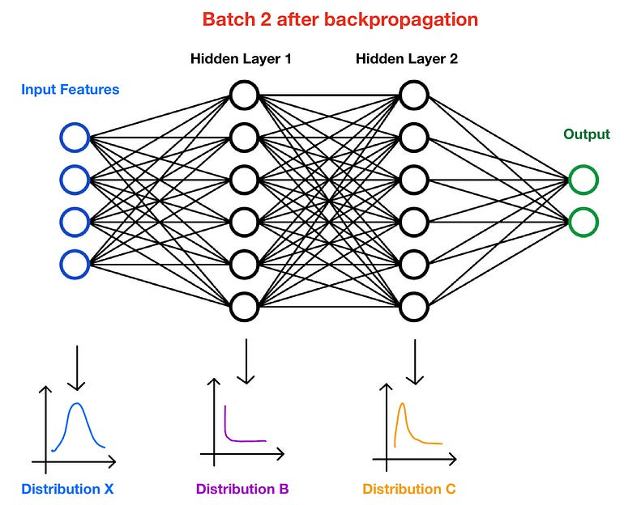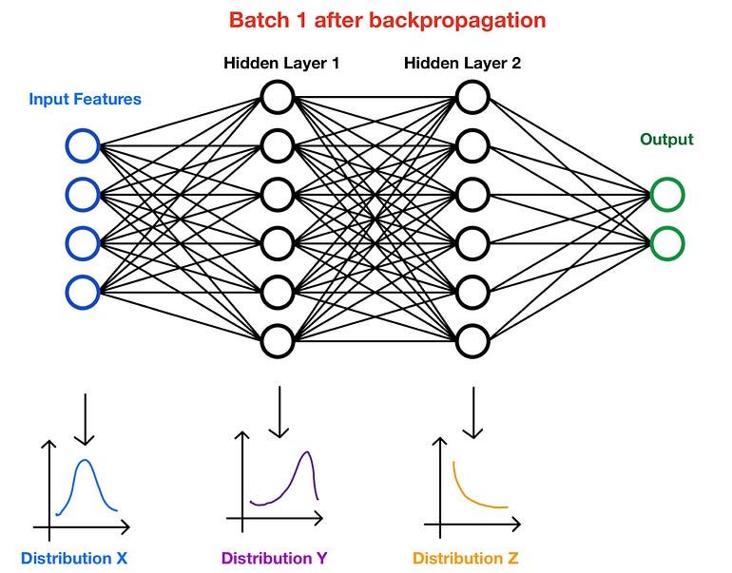

[9]

It can be seen that the distribution X remains unchanged because it is the input feature, however, for both distributions Y and Z, it can be seen that the shape of the line changed after one iteration of forward and back propagation to the batch.

Batch Normalization was then introduced in 2015 to mitigate the effects of Internal Covariate Shifts. It is called Batch Normalization because in deep learning approaches, datasets are very likely to be divided into batches, and normalization is the technique applied to stabilize the distribution, hence named Batch Normalization.

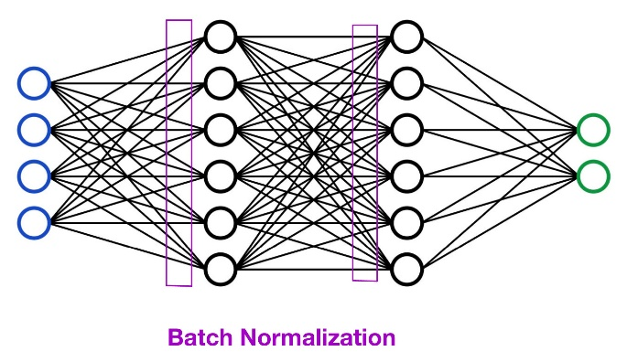

Batch Normalization takes place before putting in data into each hidden layer.

“Batch Normalization operates by subtracting the mean/expectation (**Shift**) and dividing by the standard deviation (**Scale**). While this normalization step aids in stabilizing and accelerating training, this could result in information loss (**Shift & Scale**)” [9]

|  |
| --- |
| Architecture |
| Input 64, relu + Batch Norm |
| Conv2D 64, relu + Batch Norm + MaxPooling 2 |
| Conv2D 128, relu + Batch Norm |
| Conv2D 128, relu + Batch norm + MaxPooling 2 |
| Conv2D 256, relu + Batch Norm |
| Conv2D 256, relu + Batch Norm + MaxPooling 2 |
| Conv2D 512, relu + Batch Norm |
| Conv2D 512, relu + Batch Norm + MaxPooling 2 |
| Dense 256, relu + Batch Norm |
| Dropout, 0.5 |
| Dense 256, relu + Batch Norm |
| Dropout, 0.5 |
| Output 10, Softmax |

|  |
| --- |
| Other Hyperparameters |
| Optimizer: Adam |
| Learning Rate: 1e-4 / 0.0001 |
| Batch size: 32 |
| Epoch: 100 |

Batch Norm has been added to essentially all the layers with units/filters.

Number of Param: 8,035,658 (trainable) + 4,864 (non-trainable)

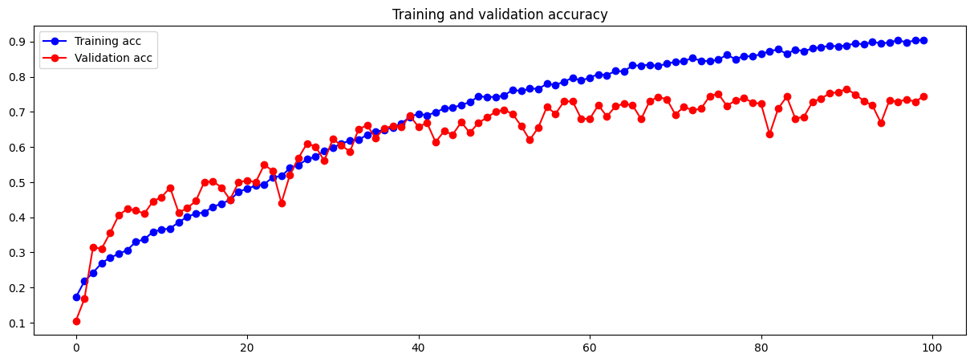

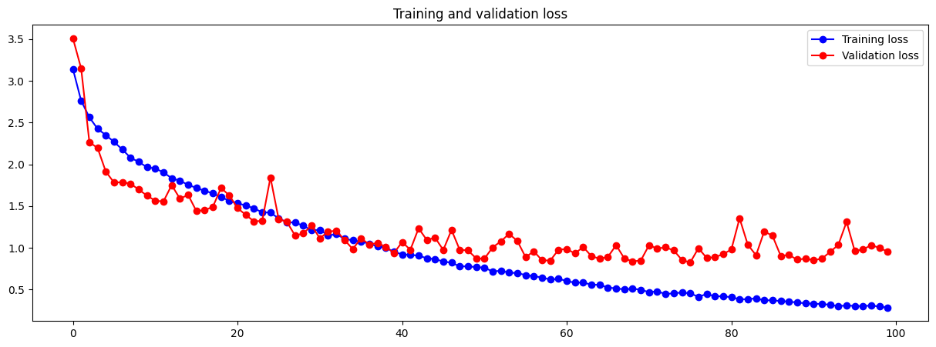

Non-trainable parameters were introduced because of the additional parameters (Shift + Scale) being involved to normalize and scale the activations within each layer.

The training loss seem to be starting to converge after training this model. One notable change observed here would be the increase of y axis limit for loss chart. However, this observation could be explained by how batch normalization works above. Because of how batch normalization operates by shifting and scaling data before putting it through the next layer, there is a risk of information loss at early stages of model training, thus the increase in y axis limit for the loss chart.

There is no sign of overfitting which is viable, but the divergence of training and validation charts starts at around epoch 50 now.

The implementation of batch normalization has benefitted the validation accuracy significantly with a new peak of 75%, an increase of 5% from the previous model.

## Model 11 – Testing Padding

By default, in Conv2D layers, the padding parameter is set to ‘Valid’ where no padding take place, resulting in reduced spatial dimensions. What padding does is to basically add extra pixels to compensate for the missing ones to fulfil the spatial dimension requirement. Thus, preserving the spatial dimension of the input image as it passes through the convolutional layers.

Without padding, the spatial dimensions of the image decrease after each convolutional operation, potentially losing valuable edge or corner information. With padding, it helps retain edge information, important for detecting features at or near the borders of images.

To apply padding, we add the parameter padding=’same’, where zeros will be added to maintain the input size so that the output dimensions remain the same as the input

|  |
| --- |
| Architecture |
| Input 64, relu, padding + Batch Norm |
| Conv2D 64, relu, padding + Batch Norm + MaxPooling 2 |
| Conv2D 128, relu, padding + Batch Norm |
| Conv2D 128, relu, padding + Batch norm + MaxPooling 2 |
| Conv2D 256, relu, padding + Batch Norm |
| Conv2D 256, relu, padding + Batch Norm + MaxPooling 2 |
| Conv2D 512, relu, padding + Batch Norm |
| Conv2D 512, relu, padding + Batch Norm + MaxPooling 2 |
| Dense 256, relu + Batch Norm |
| Dropout, 0.5 |
| Dense 256, relu + Batch Norm |
| Dropout, 0.5 |
| Output 10, Softmax |

|  |
| --- |
| Other Hyperparameters |
| Optimizer: Adam |
| Learning Rate: 1e-4 / 0.0001 |
| Batch size: 32 |
| Epoch: 100 |

Padding=’same’ added to every Conv2D layer.

Number of Params: 15,375,690 (trainable) + 4,864 (non-trainable)

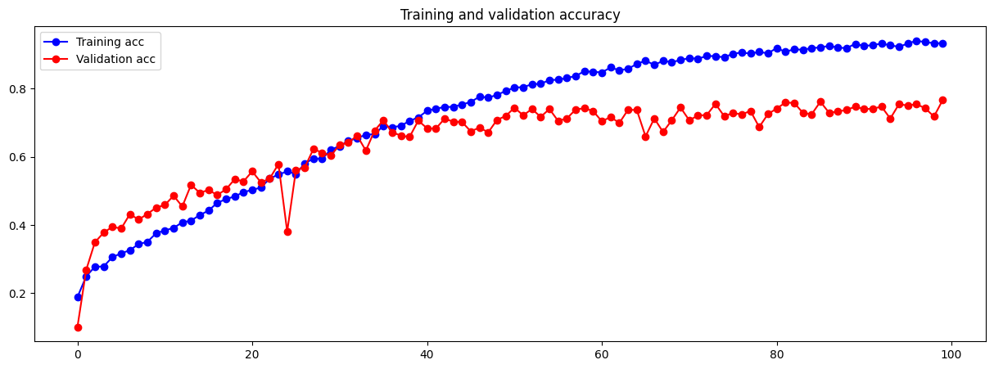

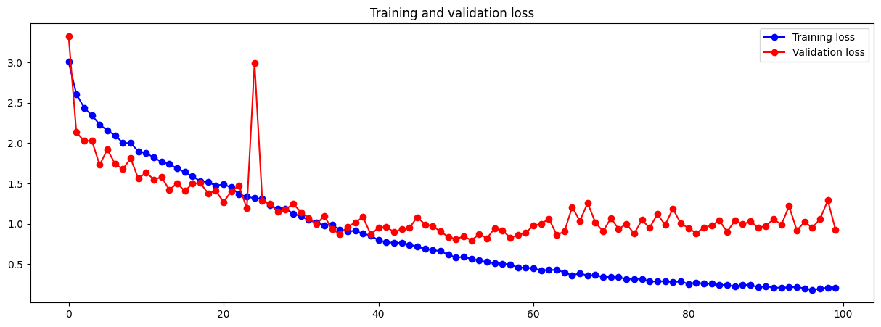

At the end of the model training, validation accuracy has reached a new peak of 76%, a 1% increase from the previous model. However, divergence of training and validation starts at an earlier epoch, the 40th epoch and the gap between the training and validation data has increased once again. Not only that, when I was training this model, the fan of my computer started going faster and the temperature of my GPU increased by around roughly 10°C.

From then on, I have decided to not proceed model tuning with padding because of the increased computational complexity and potential overfitting from happening as it may enable the model to memorize noise present in the added border pixels.

## Model 12 to 17 – Learning Rate Tuning

Fine-tuning the learning rate hyperparameter while using the Adam optimizer is essential for achieving faster convergence, stability during optimization, preventing divergence that leads to overfitting, and ultimately improving the model’s performance and generalization capabilities.

However, tuning the learning rate is often considered challenging due to its sensitivity and its significant impact on the training process and the complexity involved in finding the optimal value.

There were 6 approaches of tuning learning rate done from initial baseline learning rate of 1e-4 / 0.0001.

1. 5 * 1e-4 / 0.0005
2. 1e-3 / 0.001
3. 2*1e-3 / 0.002
4. 0.9 * 1e-3 / 0.0009
5. Decaying from 1e-3 to 5*1e-4 / 0.001 to 0.0005
6. Decaying from 7*1e-4 to 3*1e-4 / 0.0007 to 0.0004

|  |
| --- |
| Architecture |
| Input 64, relu + Batch Norm |
| Conv2D 64, relu + Batch Norm + MaxPooling 2 |
| Conv2D 128, relu + Batch Norm |
| Conv2D 128, relu + Batch norm + MaxPooling 2 |
| Conv2D 256, relu + Batch Norm |
| Conv2D 256, relu + Batch Norm + MaxPooling 2 |
| Conv2D 512, relu + Batch Norm |
| Conv2D 512, relu + Batch Norm + MaxPooling 2 |
| Dense 256, relu + Batch Norm |
| Dropout, 0.5 |
| Dense 256, relu + Batch Norm |
| Dropout, 0.5 |
| Output 10, Softmax |

|  |
| --- |
| Other Hyperparameters |
| Optimizer: Adam |
| Learning Rate: 1 to 6 stated above |
| Batch size: 32 |
| Epoch: 100 |

To save space in the report and a better visual representation to compare effectiveness of each approach, I have trained each approach individually and plotted the performance metrics against one another in a single line plot with multiple lines differentiated by unique colours.

Number of Params for all 6 models: 8,035,658 (trainable) + 4,864 (non-trainable)

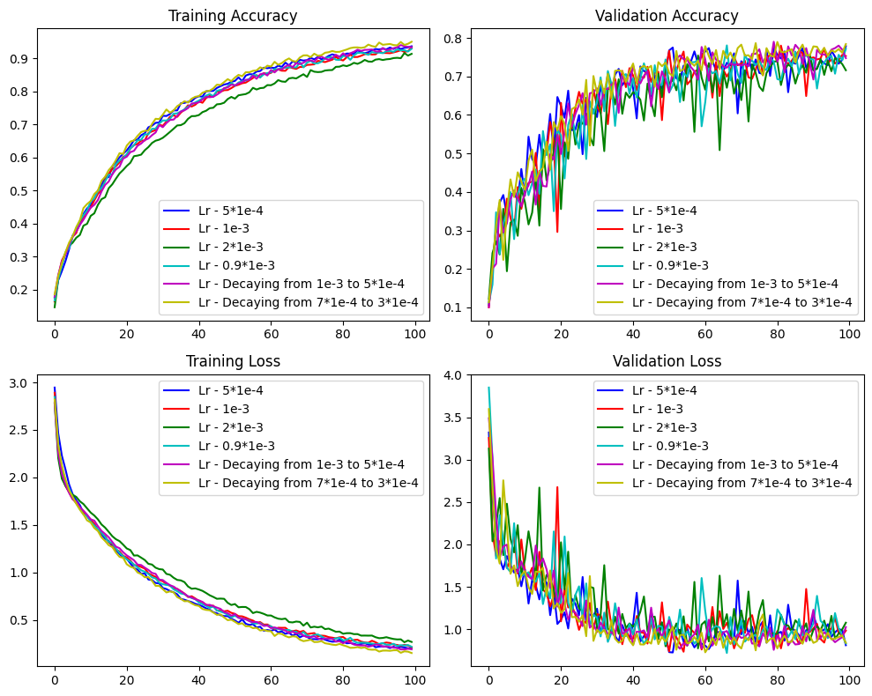

The visual representation above may not be ideal due to the number of unique lines and how each perform differently across the 100 epochs, I have decided to plot only the last 20 epochs.

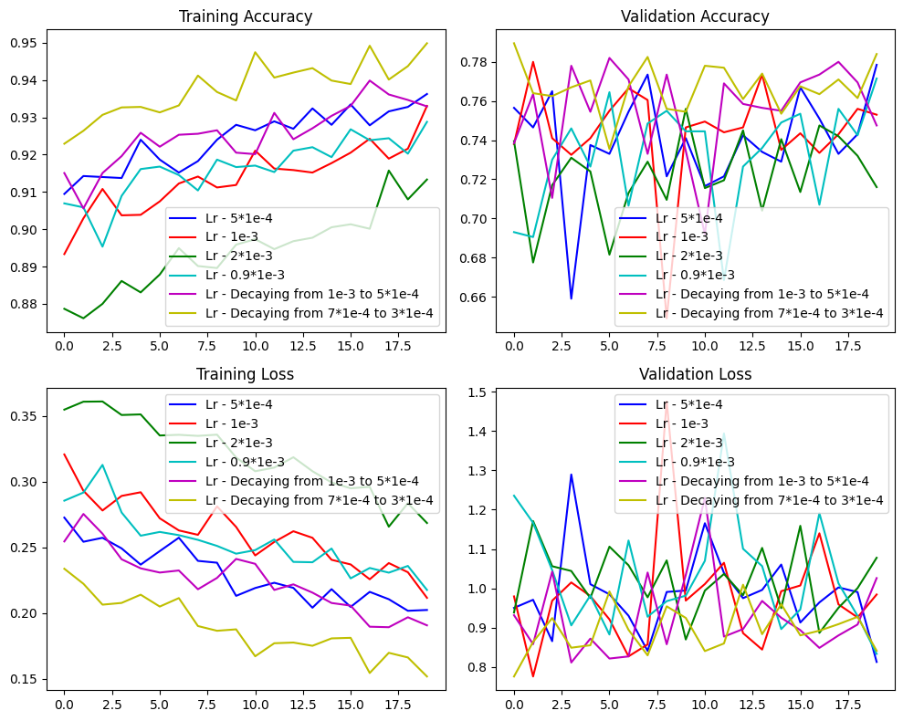

At one glance, I was able to tell that approach 6 (i.e. Decaying learning rate from 0.0007 to 0.0003) performed the best among all other approaches. Model with this learning rate achieved the highest for training accuracy, with most peaks among all other approaches for validation accuracy and lowest training loss. For validation loss, there is greater fluctuation not only for model from approach 6 but all the models. Nevertheless, if we were to imagine how training and validation loss are being plotted in the same line chart, we can conclude with high confidence that model from this approach had the largest gap but also achieved the highest validation accuracy of 78%. However, considering other training loss and validation loss for other approaches, truth to be said, all of them are starting to benefit at a different speed.

The approach to using decaying learning rate was to use ‘LearningRateScheduler’ class in Keras Callback. The decay factor is calculated by arbitrary selection of initial learning rate I wish to start training my model which is 7*1e-4 / 0.0007 and have a learning rate of 3*1e-4 / 0.0003 at the end of the model training (i.e. at 100th epoch). For each subsequent epoch, the learning rate is multiplied by the decay factor, causing the learning rate to decrease over epochs, reducing the value progressively as training progresses.

The intention of this approach is to fine-tune and converge the model to a potentially better minimum as the optimization progresses. By reducing the learning rate over epochs, it may help in reaching a more optimal solution by allowing the model to explore the loss landscape more efficiently especially in later stages of training.

The decision of initial learning rate of 7*1e-4 and final learning rate of 3*1e-4 was mostly inspired by the performance learning rate 1e-3 where the magnitude of fluctuation was more drastic and the previous decaying approach 1e-3 to 5*1e-4 where there was better performing metrics scores.

## Model 18 to 21 – Tuning Batch Size

After doing research on batch size, I found out that the more acceptable batch sizes in deep learning are batch sizes that follow the power of 2 starting from 16 until 1024. [10]

Batch size mainly has effect on the convergence and stability of the model. Smaller batch size often led to slower but more stable convergence, while for larger batch size it’s the opposite. Smaller batch sizes introduce more noise in gradient estimation but offer better generalization while larger batch size provide more accurate gradient estimates but might lead to quicker convergence to suboptimal solutions.

One challenge I faced when tuning and trying different learning rate was the computational efficiency. Larger batch size requires a lot of computational resources to compute an epoch but requires fewer epochs to converge.

Similar to learning rate, there were 4 approaches of tuning batch size done from initial baseline batch size of 32.

1. 64
2. 16
3. 100 (not a power of 2 because when trying to run 128, model constantly gets interrupted halfway due to lack of memory resource)

|  |
| --- |
| Architecture |
| Input 64, relu + Batch Norm |
| Conv2D 64, relu + Batch Norm + MaxPooling 2 |
| Conv2D 128, relu + Batch Norm |
| Conv2D 128, relu + Batch norm + MaxPooling 2 |
| Conv2D 256, relu + Batch Norm |
| Conv2D 256, relu + Batch Norm + MaxPooling 2 |
| Conv2D 512, relu + Batch Norm |
| Conv2D 512, relu + Batch Norm + MaxPooling 2 |
| Dense 256, relu + Batch Norm |
| Dropout, 0.5 |
| Dense 256, relu + Batch Norm |
| Dropout, 0.5 |
| Output 10, Softmax |

|  |
| --- |
| Other Hyperparameters |
| Optimizer: Adam |
| Learning Rate: Decaying from 7*1e-4 to 3*1e-4 |
| Batch size: 1 to 3 stated above |
| Epoch: 100 |

Similar to learning rate tuning, to save space in the report and a better visual representation to compare effectiveness of each approach, I have trained each approach individually and plotted the performance metrics against one another in a single line plot with multiple lines differentiated by unique colours.

Number of Params for all 4 models: 8,035,658 (trainable) + 4,864 (non-trainable)

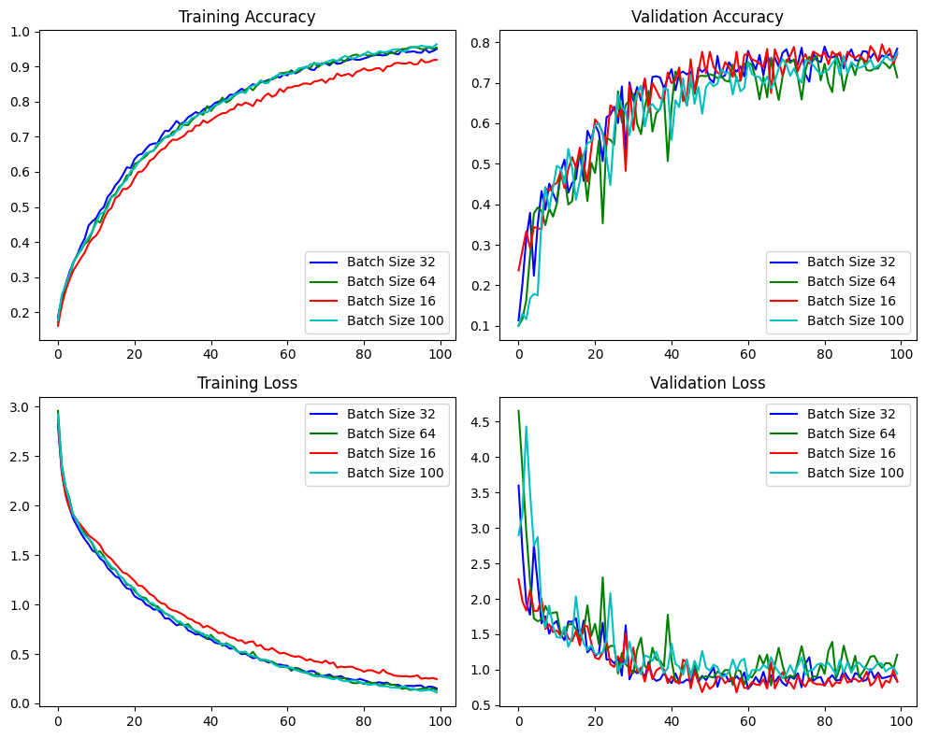

The visual representation above may not be ideal due to the number of unique lines and how each perform differently across the 100 epochs, I have decided to plot only the last 20 epochs.

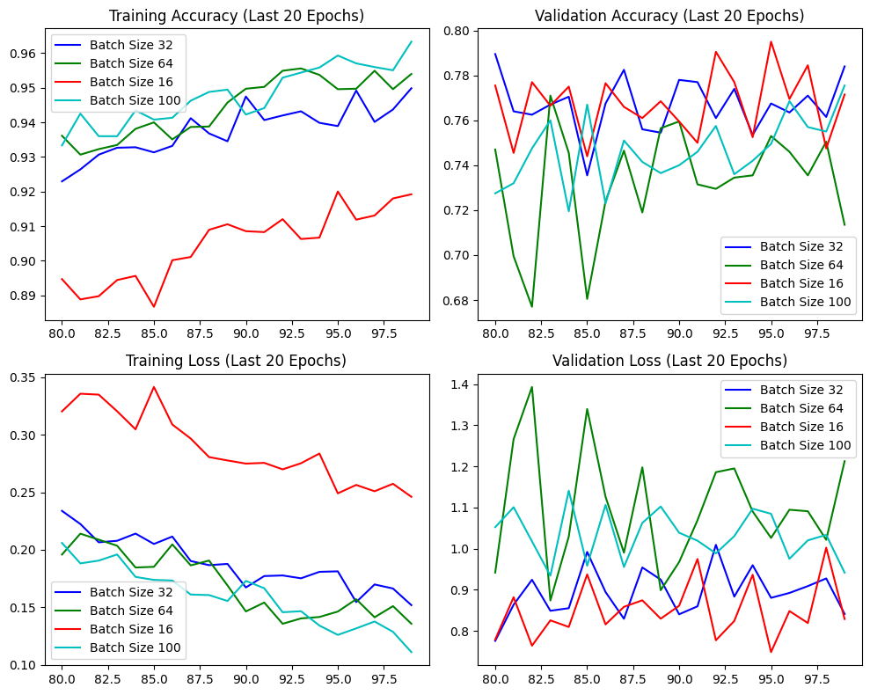

Since there is normally a pattern to when overfitting occurs, judging by the imagery gap between training and validation accuracy, I can conclude that batch size 16 has least magnitude of overfitting. Batch size 32 performed the second best mainly based on validation accuracy. However, I decided to proceed tuning other parameters with the original batch size of 32 because as mentioned smaller batch size often introduce noise in the gradient estimate during the training process and I’m also aware that my dataset is rather noisy from the start, Thus, to maintain consistency of data characteristics as much as possible, batch size 32 was my final decision.

## Model 22 – Tuning Data Augmentation Transformer

Normally finding the optimal hyperparameters can be done using a concept called GridSearch where we will put in the possible combination of parameter we wish to test and GridSearch function will run the model while iterating each unique combination of parameter to find the optimal combination. However, due to the unfamiliarity of how this concept works in Deep Learning, higher computational utilization, and most importantly time, this approach was not used here.

Initially, I’ve listed an array of different combinations to be used for each transformation.

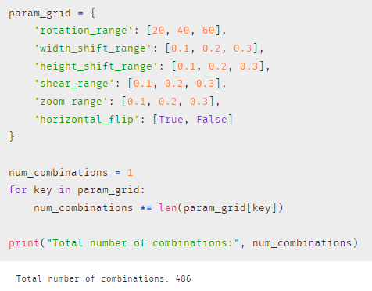

However, after calculating the number of combinations there is to be tested, which is 486 unique combinations, I made an estimate that this GridSearch process will take about 22 days straight, which definitely cannot be done within the assignment period.

Thus, I’ve decided to scale down to only 2 transformation and 2 different values each, ending up with 4 different combinations.

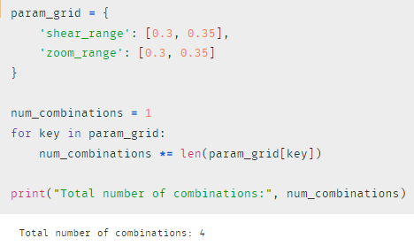

A similar approach to GridSearch was attempted here by using for loops and training the 4 combination of model and finding the best parameter combination by using the one with the highest validation accuracy.

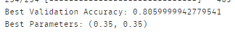

The transformers that are being tuned are shear range and zoom range. To put these in simpler terms, shear range involved shifting one part of the image in a fixed direction, creating a distorted or slanted effect while for zoom range, it involves changing the scale or magnification level of the image, either zooming in or out.

Shearing will more likely improve generalization by simulating variations in perspective, it enables the model to generalize better to unsee or distorted images in the validation dataset.

Zooming will more likely improve robustness which enhance the model’s ability to recognize objects regardless of their size of scale.

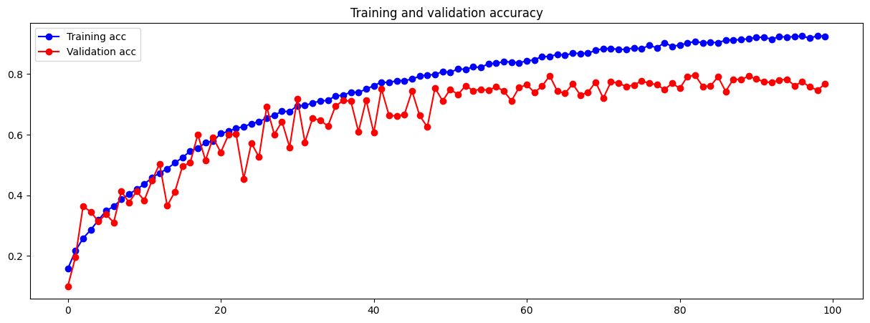

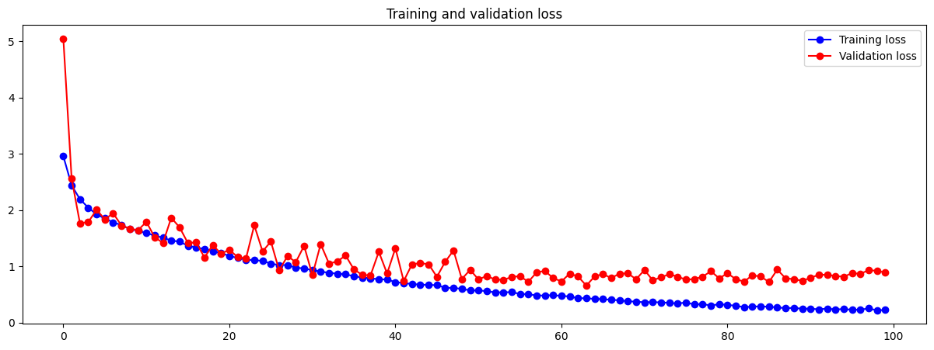

It can be seen that for the first epoch of validation loss, it starts off with an estimated value of 5. A possible reason for this occurrence would be because of the increase in shear range and zoom range, which led to more aggressive distortions and variations applied to the training images. Consequently, the model might struggle to generalize well to these heavily distorted images, leading to poor validation performance at the start. These aggressive distortions and variations also affected the early stage of training process where there are frequent fluctuations happening for the first 50 epochs. After 50 epochs, the model started to generalize and stabilize the performance of unseen data.

The validation accuracy still hovers around the range of 76% to 78%, but since these data augmentation transformation applied seem to be effective in generating more robust data in general, I have decided to keep these configurations and proceed with other tuning.

## Model 23 to 25 – Tuning Activation Function

Activation functions play a crucial role in determining model performance because they add non-linearity to neural networks, enabling them to learn and capture complex patterns within data.

Here are the activation functions we will be testing including ReLu that’s been used throughout the model building and tuning so far.

* ReLU (**Re**ctified **L**inear **U**nit)
* Leaky ReLU
* ELU (**E**xponential **L**inear **U**nits)
* Swish

**ReLU:**

This activation function is one of the most common used activation functions in deep learning. The function returns a value of 0 if the input is negative else returns the positive value back.

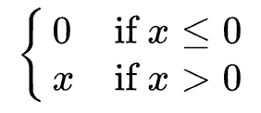

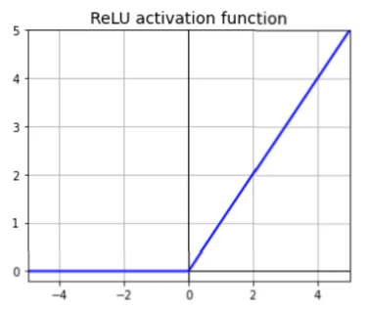

The output of ReLU does not have a maximum value which helps Gradient Descent. One downside of ReLU is that it will suffer from a problem known as dying ReLU.

When training a neural network, some neurons might “die”, meaning they stop working by always outputting the value 0. This happens when a neuron’s weights are adjusted in a way that makes the total input it receives always negative for every image sample in the training set.

Once a neuron consistently gets negative inputs, it activates a part of the network called ReLU, which makes the neuron output zeros from that point onwards. And since the ReLU function gives a zero gradient when its input is negative, the neurons does not change anymore during training. [11]

**Leaky ReLU:**

Simply speaking, Leaky ReLU is an improvement over the ReLU activation function. It is like ReLU but it will never have the problem of dying ReLU stated above.

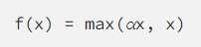

Alpha defines how much the function leaks. It is normally set to 0.01 or 0.001. It is the slope of the function for negative input values, and it ensures that there will be no dying neurons. [11]

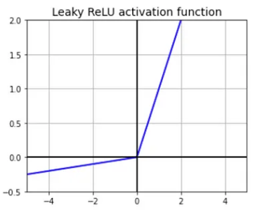

**ELU:**

ELU is a variation of ReLU with a better output for negative input values.

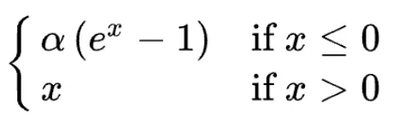

Alpha controls the value to which an ELU saturates for negative net inputs. [11]

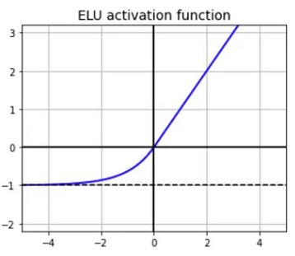

Compared to ReLU and Leaky ReLU, ELU uses a log curve for the negative input values.

One downside of ELU is that it takes a longer time to compute value put through, but during training this is compensated by the faster convergence rate.

**Swish:**

Google Brian Team proposed this Swish activation function to try and replace the successful and widely used activation function ReLU. Through their experiments, it was shown that Swish tends to work better than ReLU on deeper models across a number of challenging datasets. [12]

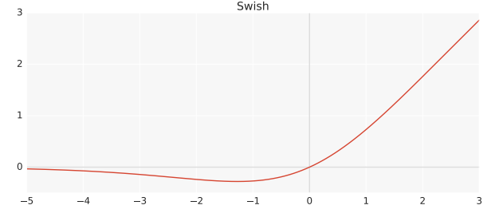

The main issue with ReLU lies in the occurrence of “dead” neurons (i.e. dying ReLU) where a percentage of the network's neurons may become inactive during training, leading to stalled learning. Swish, an alternative activation function, overcomes this by offering a smooth, non-monotonic function that consistently outperforms ReLU in deep networks. With self-gating and higher performance on deep layers, Swish mitigates the dead neuron problem and optimizes training, showing superiority, especially in very deep networks and varying batch sizes. [12]

|  |
| --- |
| Architecture |
| Input 64, [activation function] + Batch Norm |
| Conv2D 64, [activation function] + Batch Norm + MaxPooling 2 |
| Conv2D 128, [activation function] + Batch Norm |
| Conv2D 128, [activation function] + Batch norm + MaxPooling 2 |
| Conv2D 256, [activation function] + Batch Norm |
| Conv2D 256, [activation function] + Batch Norm + MaxPooling 2 |
| Conv2D 512, [activation function] + Batch Norm |
| Conv2D 512, [activation function] + Batch Norm + MaxPooling 2 |
| Dense 256, [activation function] + Batch Norm |
| Dropout, 0.5 |
| Dense 256, [activation function] + Batch Norm |
| Dropout, 0.5 |
| Output 10, Softmax |

|  |
| --- |
| Other Hyperparameters |
| Optimizer: Adam |
| Learning Rate: Decaying from 7*1e-4 to 3*1e-4 |
| Batch size: 32 |
| Epoch: 100 |

Just like testing of different learning rate and batch size, different activation functions were too tested and plotted in one chart.

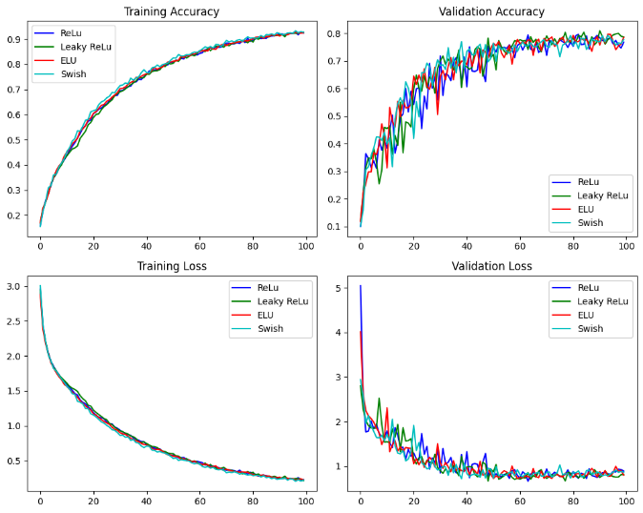

Last 20 epochs:

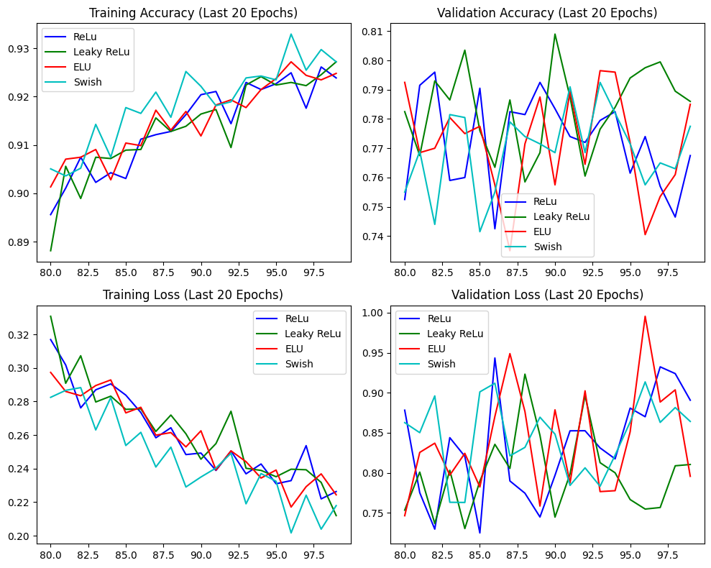

Since the distribution of performance metrics for all the activation functions are around the same range and characteristics, I picked the best activation function based on the one thing that stood out to me which was the peak for Leaky ReLU in validation accuracy of accuracy close to 81%.

Though Swish was proven to perform better than ReLU and its variation, it’s more suitable for deeper models and across challenging datasets. Perhaps if we’re working with the whole 101 food type it will be effective, but for this assignment, we’re only working with 10.

## Model 26 – Increase Kernel Size

The current kernel size set for all convolutional layers is (3, 3). Larger kernel sizes capture more extensive spatial information but increase parameters and computation, suitable for complex features. Smaller kernels focus on local details, faster computation, and are ideal for simpler features.

Smaller kernels sizes over fully connected networks are normally preferred for its weight sharing that leads to lesser weights for back propagation process.

We will be testing kernel size of (4, 4) here to capture the changes in model performance.

Number of Params: 9,581,194 (trainable) + 4,864 (non-trainable)

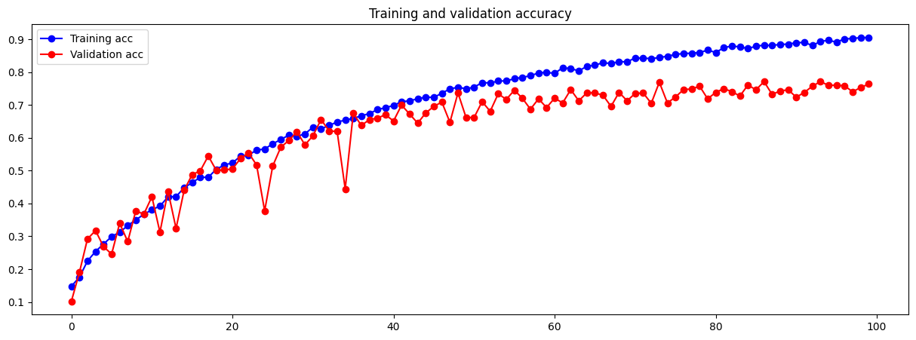

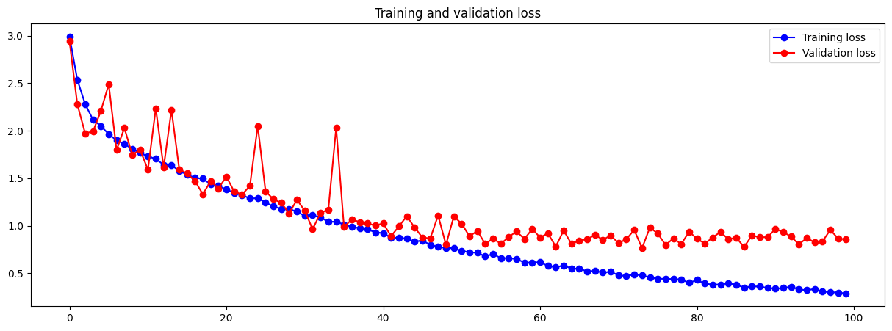

Greater fluctuating spikes are seen at the start of training, <40 epochs, and its starts to stabilize afterwards. Similar to when I was testing padding, the computational resource utilization was far greater than normal when running kernel size of (4, 4). Moreover, there isn’t an improvement in terms of validation accuracy score.

“**2x2** and **4x4** are generally **not preferred** because odd-sized filters symmetrically divide the previous layer pixels around the output pixel. And if this symmetry is not present, there will be distortions across the layers which happens when using an even sized kernels, that is, 2x2 and 4x4. So this is why we don’t use 2x2 and 4x4 kernel sizes.” [13]

Perhaps the distortion of data is a possible reason why there is more fluctuation happening in the early stages of model training, similar to what happened when shear range was increased when tuning data augmentation transformers.

## Model 27 to 32 – Kernel Regularizer

Kernel Regularizer tested will be L1 and L2 regularizer. If we were to describe what these regularizer do in one sentence, it would be that “these types of regularization keeps the weights of the neural network small by adding a penalizing term to the loss function”.

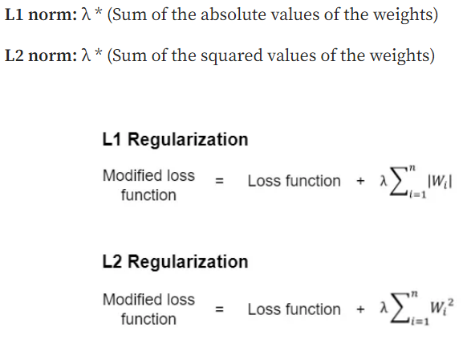

[14]

Lambda is the regularization factor that controls the level or strength of regularization. It can take any values between and inclusive of 0 and 1. Keras default has lambda set to 0.01.

The difference between how L1 and L2 regularization works:

* By function: With L1, more weights are equal to 0, thus nodes with these weights are completely removed from the network. With L2, weights are adjusted to a very small value that is close to 0 but is never 0. L2 decreases the effect of the nodes on the output, but these nodes are not completely removed from the network.
* By usage: L2 is more used more widely than L1 in deep neural networking.
* By formation: In L1, the sum of absolute values of the weight is multiplied by the lambda while for L2, the sum of the squared values of the weight is multiplied by the lambda. [14]

The sensitivity of lambda is varies for each dataset. Finding an optimal value may require many trials and errors of testing various lambda values of not only one regularizer but both.

For our approach, I will be testing three degrees of lambda for each regularizer, summing up to 6 different models to be tested. I will be applying these kernel regularizer to the dense layers.

The approaches are listed as follows:

1. L1 0.001
2. L1 0.0005
3. L1 0.0001
4. L2 0.001
5. L2 0.005
6. L2 0.0001

|  |
| --- |
| Architecture |
| Input 64, Leaky ReLU + Batch Norm |
| Conv2D 64, Leaky ReLU + Batch Norm + MaxPooling 2 |
| Conv2D 128, Leaky ReLU + Batch Norm |
| Conv2D 128, Leaky ReLU + Batch norm + MaxPooling 2 |
| Conv2D 256, Leaky ReLU + Batch Norm |
| Conv2D 256, Leaky ReLU + Batch Norm + MaxPooling 2 |
| Conv2D 512, Leaky ReLU + Batch Norm |
| Conv2D 512, Leaky ReLU + Batch Norm + MaxPooling 2 |
| Dense 256, Leaky ReLU, Kernel Reg + Batch Norm |
| Dropout, 0.5 |
| Dense 256, Leaky ReLU, Kernel Reg + Batch Norm |
| Dropout, 0.5 |
| Output 10, Softmax |

|  |
| --- |
| Other Hyperparameters |
| Optimizer: Adam |
| Learning Rate: Decaying from 7*1e-4 to 3*1e-4 |
| Batch size: 32 |
| Epoch: 100 |

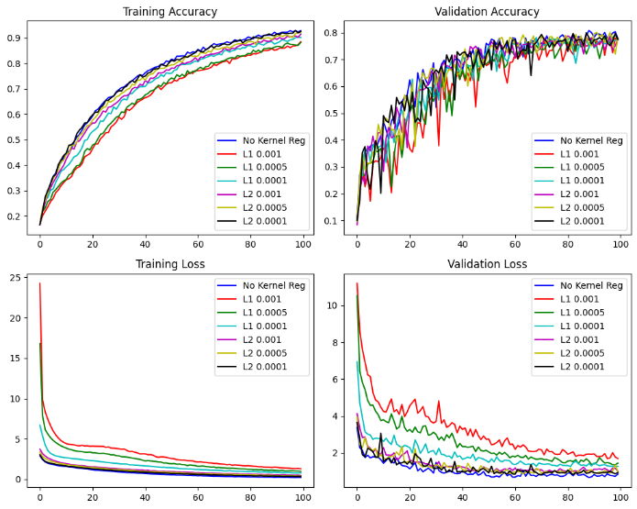

Last 20 epochs:

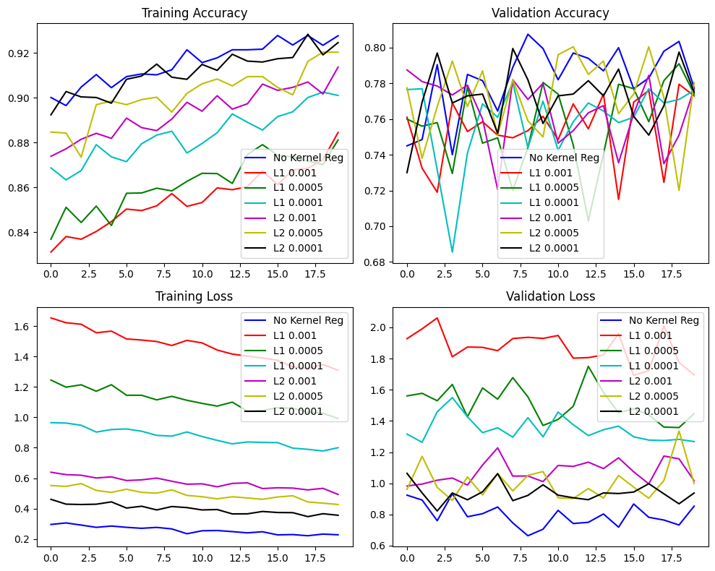

At one glance I could tell that the blue line representing No Kernel Regularizer used performed the best across all performance metrics. It achieved the lowest loss and highest accuracy for both training and validation data across all the other models tested. Although other options seem to have dealt with the problem of overfitting, if we were to look back at the plot of all 100 epochs, regularizer made it such that the initial validation loss is extremely high due to the magnitude of penalization of weights affecting model learning of data at early stage.

Thus, I’ve decided to explore another potential regularization method other than kernel regularizer.

## Model 33 – Spatial Dropout

Spatial Dropout is basically a dropout regularizer but it’s for convolutional layers. Compared to normal dropouts where neurons are ‘removed’ at random, spatial dropout focuses on dropping entire channels/filters of feature maps. This dropout disrupts the specific feature channels rather than individual neuron units, thus maintain spatial relationships within feature maps.

In summary, special dropout encourages diverse feature learning, and improve the network’s ability to generalize to new, unseen data.

|  |
| --- |
| Architecture |
| Input 64, Leaky ReLU + Batch Norm |
| Conv2D 64, Leaky ReLU + Batch Norm + MaxPooling 2 |
| Conv2D 128, Leaky ReLU + Batch Norm + Spatial Dropout |
| Conv2D 128, Leaky ReLU + Batch norm + MaxPooling 2 |
| Conv2D 256, Leaky ReLU + Batch Norm + Spatial Dropout |
| Conv2D 256, Leaky ReLU + Batch Norm + MaxPooling 2 |
| Conv2D 512, Leaky ReLU + Batch Norm + Spatial Dropout |
| Conv2D 512, Leaky ReLU + Batch Norm + MaxPooling 2 |
| Dense 256, Leaky ReLU + Batch Norm |
| Dropout, 0.5 |
| Dense 256, Leaky ReLU + Batch Norm |
| Dropout, 0.5 |
| Output 10, Softmax |

|  |
| --- |
| Other Hyperparameters |
| Optimizer: Adam |
| Learning Rate: Decaying from 7*1e-4 to 3*1e-4 |
| Batch size: 32 |
| Epoch: 100 |

Spatial Dropout strength is all set to 0.25

Number of Params: 8,035,658 (trainable) + 4,864 (non-trainable)

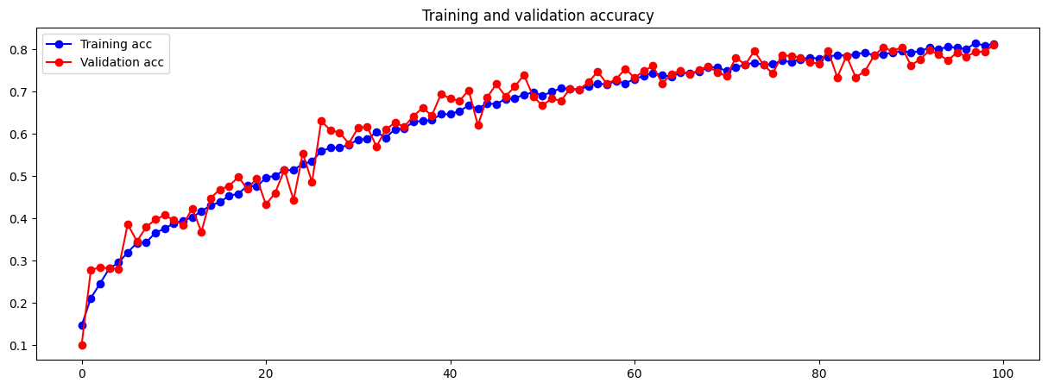

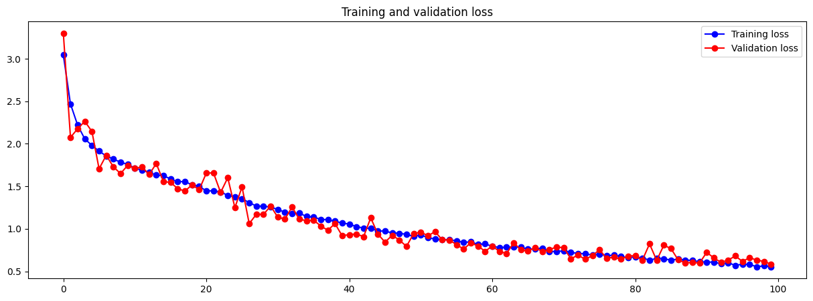

The reason why Spatial Dropout strength is set to 0.25 is to reduce the risk of information loss, in hope of regularizing the model while retaining more information.

As seen from the chart, the model has been successfully regulated with no indication of overfitting. And a bonus to that would be that the model is starting to converge too. The training accuracy peaked at 81%.

## Model 34 – Train for 200 epochs

After configuring the model architecture and fine-tuning hyperparameters, we’ve obtained a model that is satisfactory to be deemed as the final model. Since the graph shows that the loss and accuracy is starting to converge near the end, I decided to train the model on last with but with 200 epochs.

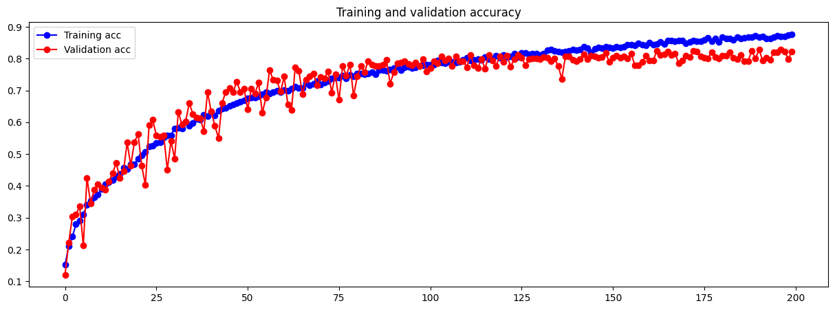

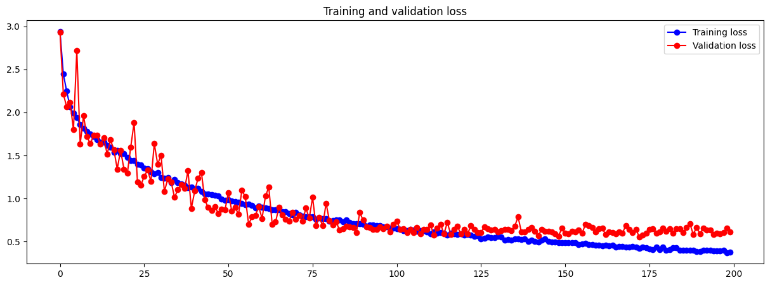

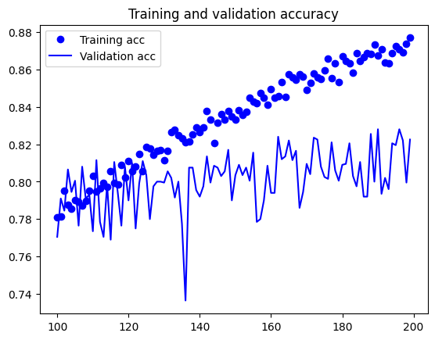It may be hard to determine the best epoch to stop at with this chart hence I’ve plotted another chart to show the performance of model from epoch 100 to 200 only.

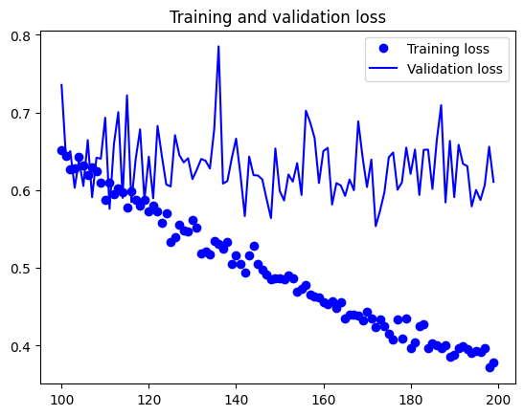

## Model 35 – Final Model

The above representation tells us that the model has started to overfit again at higher epoch. This observation could not be made from the chart of epoch 1 to 200 because of how small the range of y axis limit is compared to the greater range of y axis limit for epoch 1 to 200. At this stage I will try to find an optimal epoch and train the model one last time with that number. After careful inspection of both the chart and the verbose printed out when training the model, I have determine that epoch 163 will be my optimal epoch to train my final model to.

## Model 35 – Final Model

|  |
| --- |
| Architecture |
| Input 64, Leaky ReLU + Batch Norm |
| Conv2D 64, Leaky ReLU + Batch Norm + MaxPooling 2 |
| Conv2D 128, Leaky ReLU + Batch Norm + Spatial Dropout |
| Conv2D 128, Leaky ReLU + Batch norm + MaxPooling 2 |
| Conv2D 256, Leaky ReLU + Batch Norm + Spatial Dropout |
| Conv2D 256, Leaky ReLU + Batch Norm + MaxPooling 2 |
| Conv2D 512, Leaky ReLU + Batch Norm + Spatial Dropout |
| Conv2D 512, Leaky ReLU + Batch Norm + MaxPooling 2 |
| Dense 256, Leaky ReLU + Batch Norm |
| Dropout, 0.5 |
| Dense 256, Leaky ReLU + Batch Norm |
| Dropout, 0.5 |
| Output 10, Softmax |

|  |
| --- |
| Other Hyperparameters |
| Optimizer: Adam |
| Learning Rate: Decaying from 7*1e-4 to 3*1e-4 |
| Batch size: 32 |
| Epoch: 163 |

|  |
| --- |
| Data Augmentation |
| Rescale 1./255 |
| Rotation Range 40 |
| Width Shift Range 0.2 |
| Height Shift Range 0.2 |
| Shear Range 0.35 |
| Zoom Range 0.35 |
| Horizontal flip True |

Number of Params: 8,035,658 (trainable) + 4,864 (non-trainable)

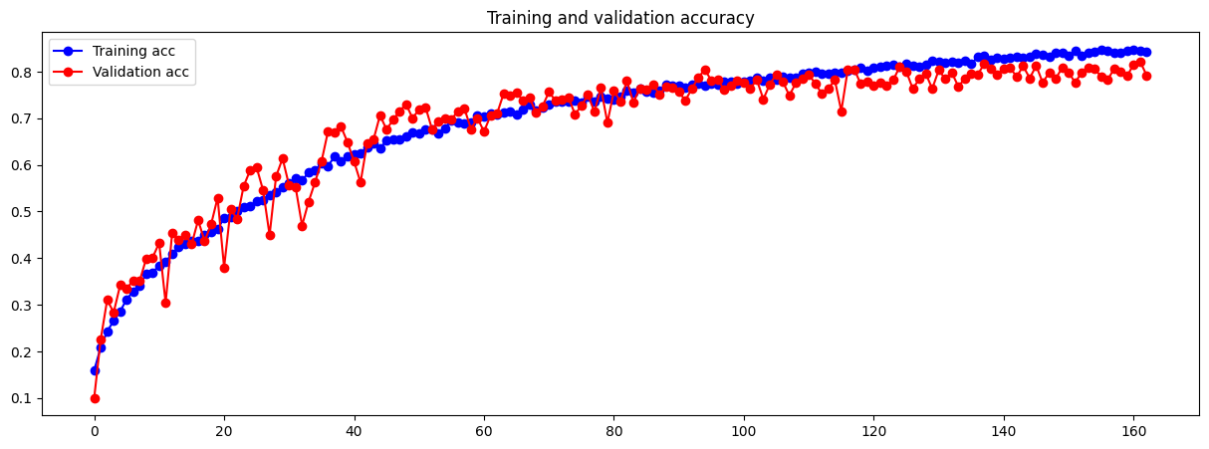

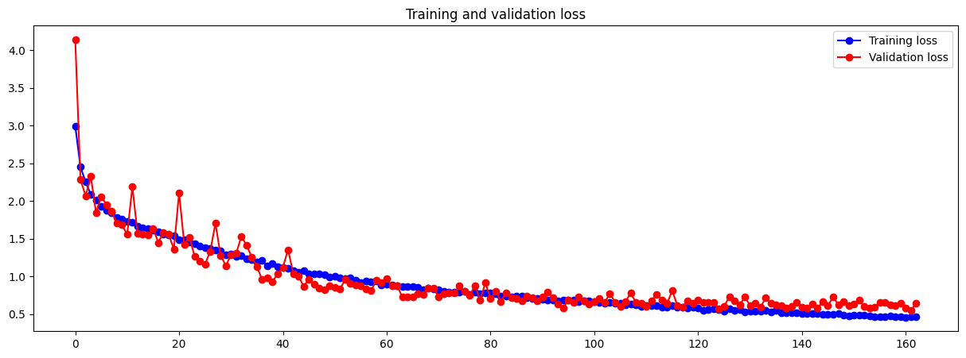

Final model peaked at a validation accuracy of 82%. This epoch was found before overfitting occurred for the previous model. Retraining the model with the same settings for the optimal epoch helps achieve a balance between model performance and generalization, preventing overfitting while maximizing the model’s ability to perform well on unseen data (used on test data later on)

# Develop the Image Classification Model with Pre-trained Models

We will be using VGG16 model available in the Keras application class to help us develop an image classification model. VGG16 is a type of CNN (Convolutional Neural Network) that is considered to be one of the best computer vision models to date.

“VGG16 is object detection and classification algorithm which is able to classify 1000 images of 1000 different categories with 92.7% accuracy. It is one of the popular algorithms for image classification and is easy to use with transfer learning.” [15]

VGG16 takes input size of (224, 224) hence we’ll be using that image size for pre-trained model section. The 16 in VGG16 implies 16 layers that are weight layers, 13 convolutional layers + 3 dense and 5 max pooling layers mixed in the process. These can be categorized into 5 blocks.

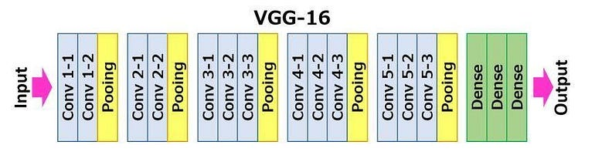

[15]

## Pre-trained 1 – Baseline

Baseline model for pre-trained section is essentially the trained classifier.

|  |
| --- |
| Architecture |
| Frozen |
| Frozen |
| Frozen |
| Frozen |
| Frozen |
| Dense 256, ReLU |
| Output 10, Softmax |

|  |
| --- |
| Other Hyperparameters |
| Optimizer: Adam |
| Learning Rate: 1e-5 / 0.00001 |
| Batch size: 32 |
| Epoch: 30 |

A low learning rate is used for initial pre-trained models to facilitate stability in pre-trained model learning and to aid in fine-tuning existing features without making significant alterations and better retain valuable knowledge built-in the pre-trained model.

Fine tuning will be done right after this baseline model.

Number of Params: 6,425,354 (trainable) + 14,714,688 (non-trainable)

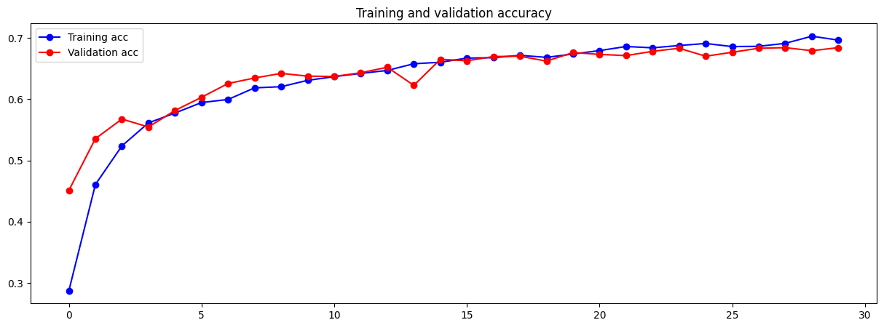

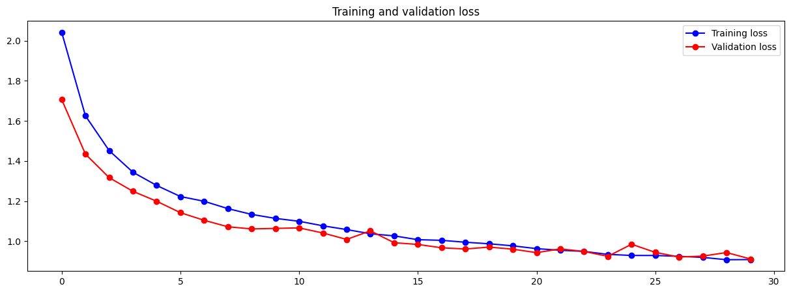

From our baseline charts above, we can see that the accuracy of both train and validation set increases gradually at the same rate and magnitude from epoch 5 onwards, indicating model is well generalized even for a baseline. A low learning rate might have played a part in achieving this result. There is no indication of overfitting too.

Let’s proceed to unfreeze the last block right after training this baseline.

## Pre-trained 2 – Fine Tuning (unfreeze 5th block)

In week 6 practical, we have learnt that all layers in the convolutional base must be frozen to be able to train a randomly initialized classifier. Which was done in pre-trained 1.

To fine-tune the model, it is only possible for the classifier on top to have already been trained beforehand. Hence, if we wish to make any changes to the user initialized classifier on top, we will have to create a new model again, train the classifier, then fine-tune. If the classifier has not been trained before fine-tuning, the error signal propagating through the network during the training will be too large and the representations previously learnt by the layers being fine-tuned would also be destroyed.

At this stage we will first unfreeze the last block and gradually progress from there on.

|  |
| --- |
| Architecture |
| Frozen |
| Frozen |
| Frozen |
| Frozen |
| Unfrozen |
| Dense 256, ReLU |
| Output 10, Softmax |

|  |
| --- |
| Other Hyperparameters |
| Optimizer: Adam |
| Learning Rate: 1e-5 / 0.00001 |
| Batch size: 32 |
| Epoch: 30 |

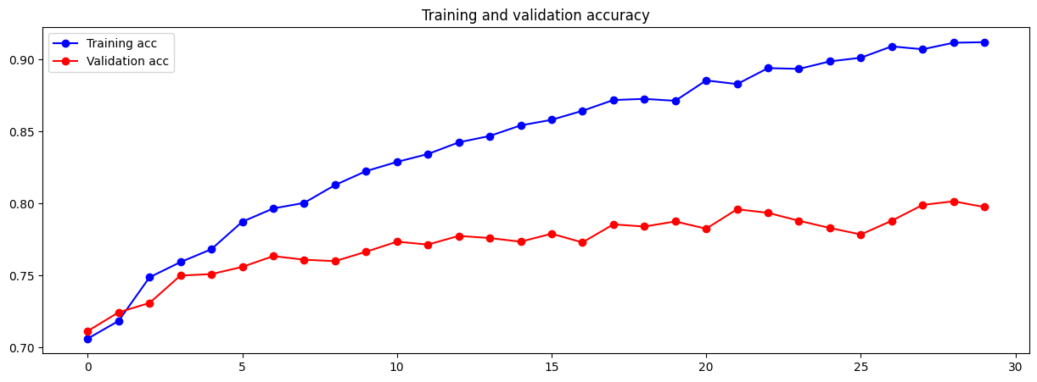

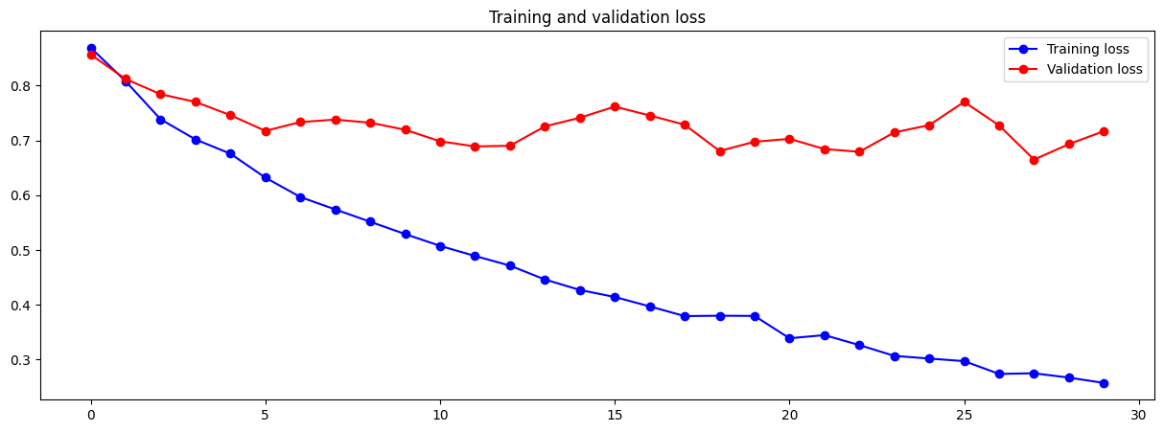

Once the 5th block has been unfroze, we can see that the training and validation accuracy has increased significantly compared to the one in baseline where only the classifier was trained. Validation reached a new high of 80% while for training it is 91%.

Well for the loss chart, it can be seen that our model is currently at risk of overfitting with great divergence in training and validation loss. If this model were to be trained with greater number of epochs, overfitting would most likely be represented clearly.

## Pre-trained 3 – Dropout

To mitigate that from happening, we will be introducing regularization technique of dropouts early on. Since divergence happened right away, we will be declaring an aggressive dropout strength of 50% (i.e. 0.5) right away.

|  |
| --- |
| Architecture |
| Frozen |
| Frozen |
| Frozen |
| Frozen |
| Frozen |
| Dense 256, ReLU + Dropout 0.5 |
| Output 10, Softmax |

|  |
| --- |
| Other Hyperparameters |
| Optimizer: Adam |
| Learning Rate: 1e-5 / 0.00001 |
| Batch size: 32 |
| Epoch: 50 |

Since dropout was added, convergence of initialized classifier is expected to take a longer time compared to model trained with epoch 30, hence the epoch to train classifier has been increased to 50.

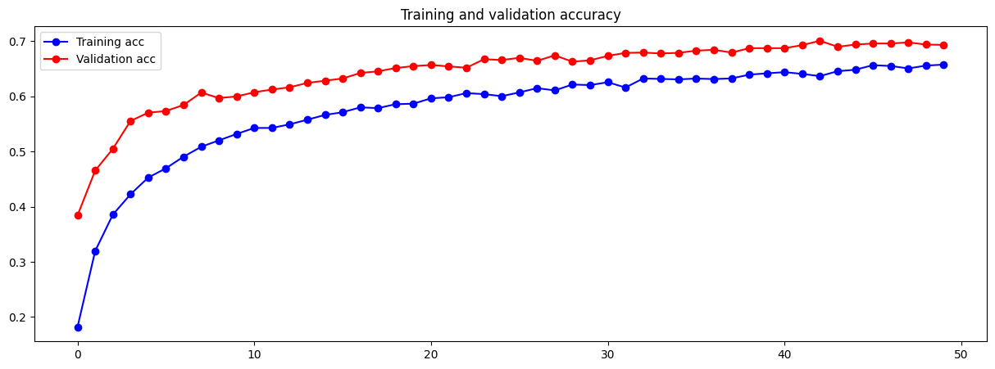

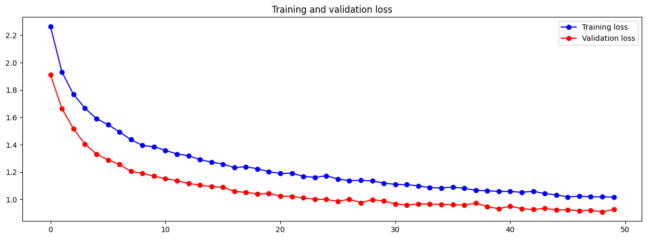

Classifier could still be trained for more epoch as convergence is not that significant, but we will proceed to unfreeze the 5th layer to do fine-tuning.

Unfreeze 5th layer:

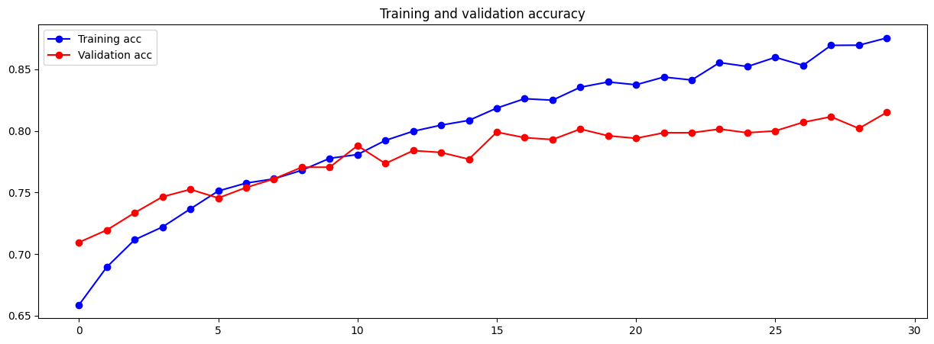

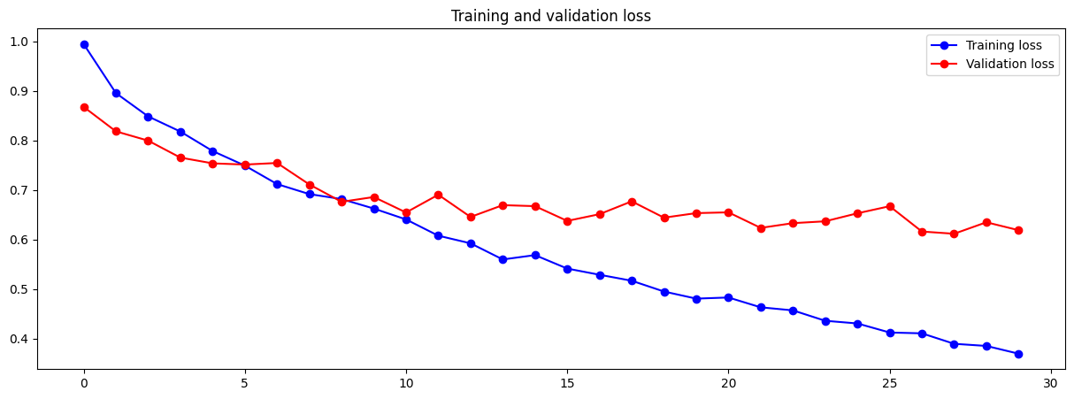

Model don’t seem to be overfitting as serious as before with the addition of dropout layer. The dropout layer helped the model with stabilization of validation dataset.

Since we now know that unfreezing blocks of the convolutional base will help increase the overall performance of the model, let’s unfreeze more block to observe the impact.

## Pre-trained 4 – Fine Tuning (unfreeze 4th block)

Classifier:

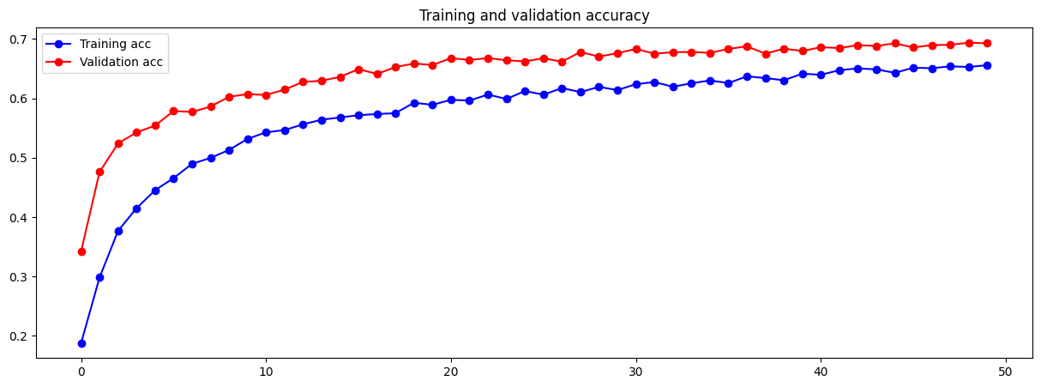

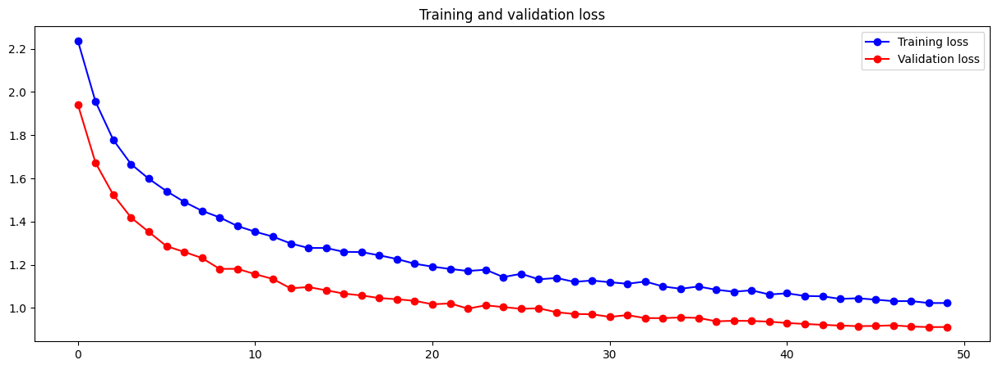

|  |
| --- |
| Architecture |
| Frozen |
| Frozen |
| Frozen |
| Unfrozen |
| Unfrozen |
| Dense 256, ReLU + Dropout 0.5 |
| Output 10, Softmax |

|  |
| --- |
| Other Hyperparameters |
| Optimizer: Adam |
| Learning Rate: 1e-5 / 0.00001 |
| Batch size: 32 |
| Epoch: 30 |

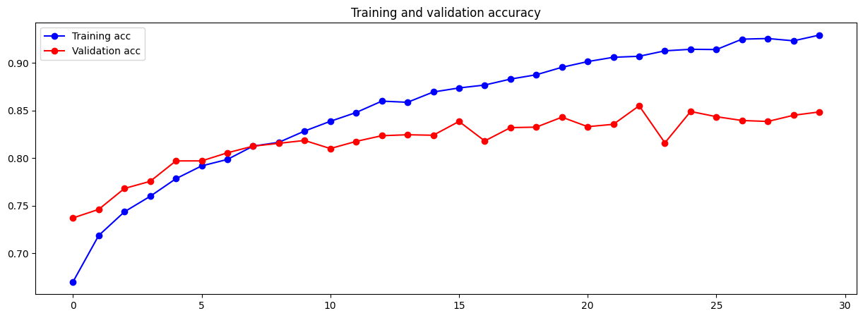

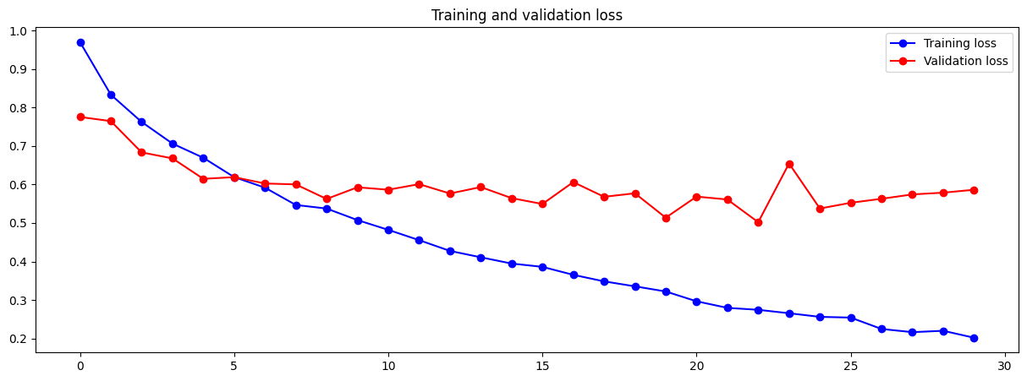

Unfreezing the 4th block did increase the performance of the model based of validation accuracy, with it reaching a new high of 85%, an increase of 5%. However, divergence now occur at a slightly earlier stage and a slight indication of overfitting can be seen at epoch 30.

## Pre-trained 5 – Lowering Batch Size

At this stage, the batch size will be decreased from 32 to 16, in hope of it generalizing the model better and mitigate overfitting.

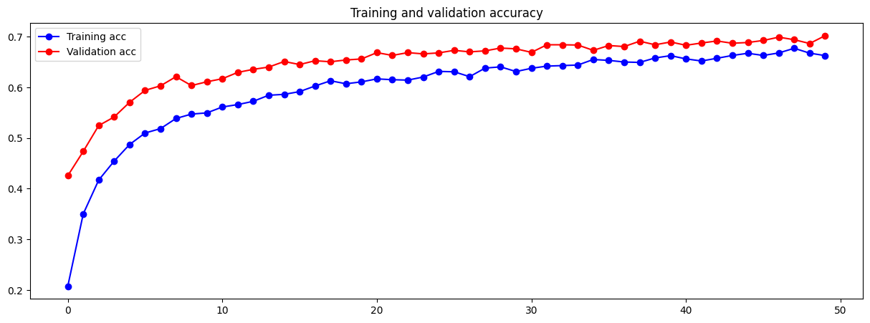

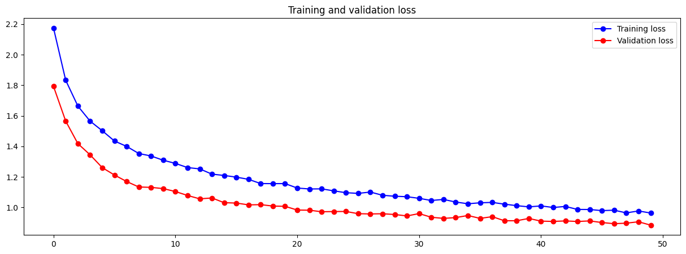

Unfreezing 4th and 5th block:

|  |
| --- |
| Architecture |
| Frozen |
| Frozen |
| Frozen |
| Unfrozen |
| Unfrozen |
| Dense 256, ReLU + Dropout 0.5 |
| Output 10, Softmax |

|  |
| --- |
| Other Hyperparameters |
| Optimizer: Adam |
| Learning Rate: 1e-5 / 0.00001 |
| Batch size: 16 |
| Epoch: 30 |

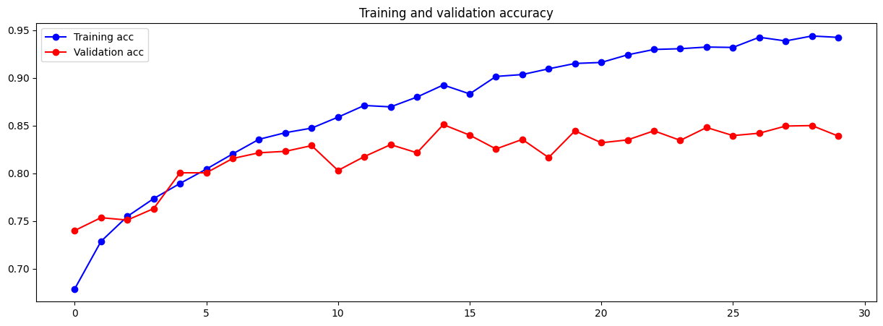

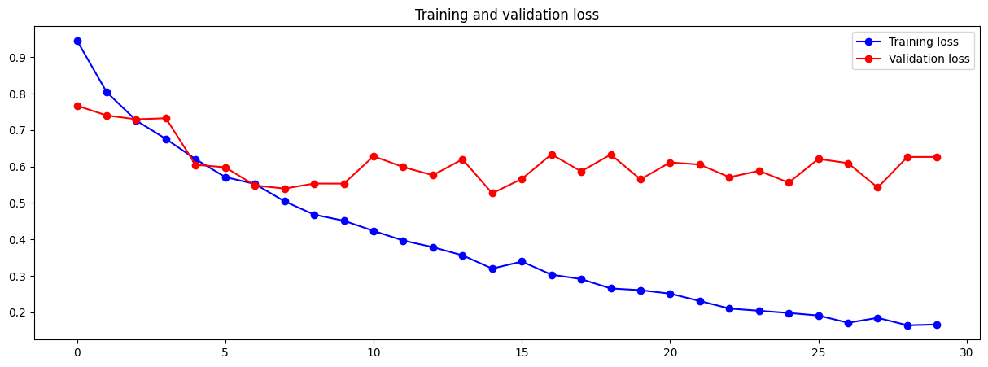

In contrast to what we hoped a lower batch size would achieve, it caused the divergence to happen even earlier than before. Moreover, although not obvious, it can be seen that it takes a slightly longer time for convergence to take place.

Lower batch size introduces more noise to gradient estimation, which may not be ideal in the context of using pre-trained models as it will affect the preexisting weights saved in the pre-trained.

## Pre-trained 6 – Kernel Regularizer

Since we’ve found out that L2 kernel regularizer is more often used in deep learning on page 38, we will be using L2 kernel regularizer of lambda value 0.001 to try and tackle the overfitting seen after unfreezing the 4th block.

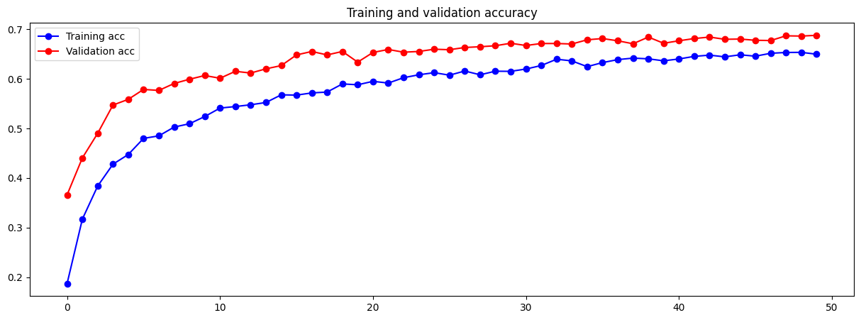

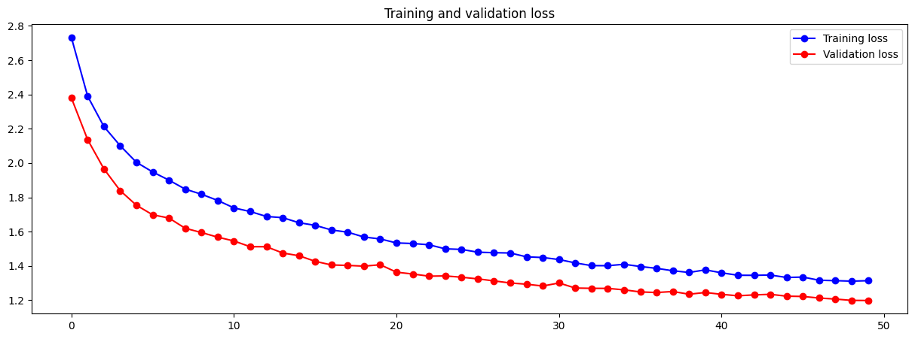

Unfreezing 4th and 5th block:

|  |
| --- |
| Architecture |
| Frozen |
| Frozen |
| Frozen |
| Unfrozen |
| Unfrozen |
| Dense 256, ReLU, L2 0.001 + Dropout 0.5 |
| Output 10, Softmax |

|  |
| --- |
| Other Hyperparameters |
| Optimizer: Adam |
| Learning Rate: 1e-5 / 0.00001 |
| Batch size: 32 |
| Epoch: 30 |

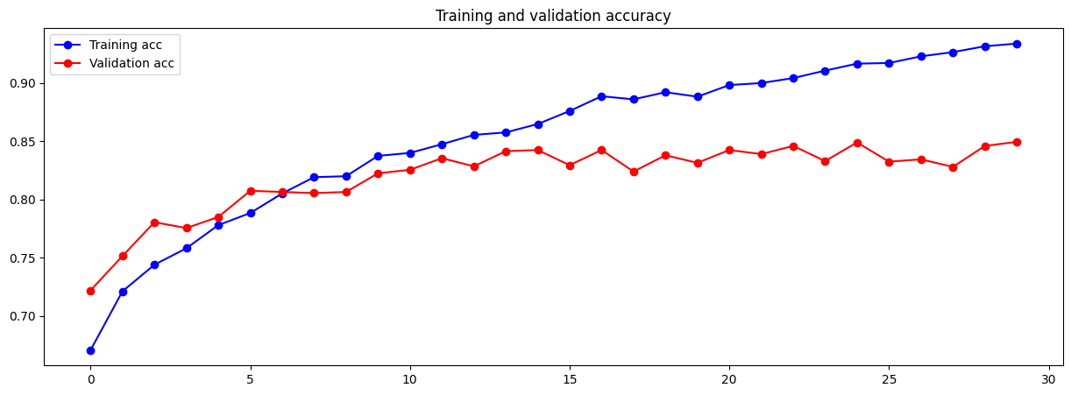

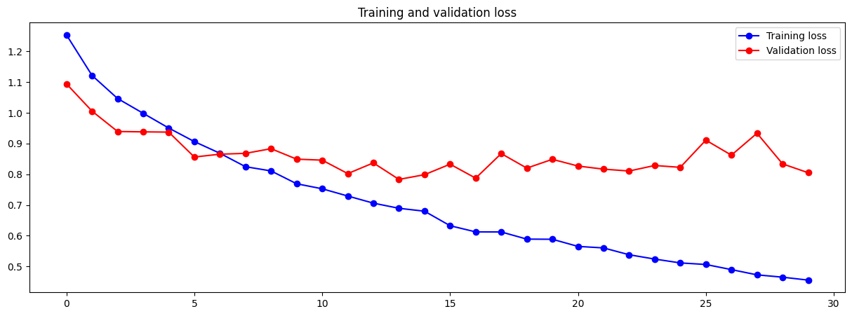

Although L2 regularizer did not mitigate the existing overfitting issue, it can be seen that the validation chart is more stable with training accuracy hovering over at around 84%.

## Pre-trained 7 – Tuning Learning Rate

Since regularization techniques of dropout and kernel regularizer has been tested and used, let’s try tuning the learning rate in hope to not only deal with the overfitting but also to achieve stable convergence and better generalization.

|  |
| --- |
| Architecture |
| Frozen |
| Frozen |
| Frozen |
| Frozen |
| Frozen |
| Dense 256, ReLU, L2 0.001 + Dropout 0.5 |
| Output 10, Softmax |

|  |
| --- |
| Other Hyperparameters |
| Optimizer: Adam |
| Learning Rate: 0.5*1e-5 / 0.000005 |
| Batch size: 32 |
| Epoch: 30 |

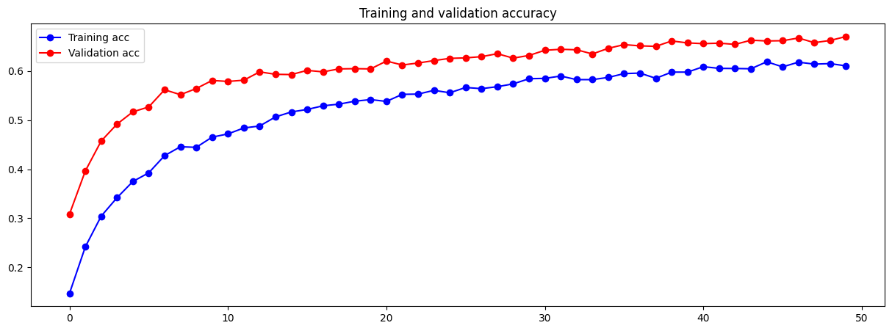

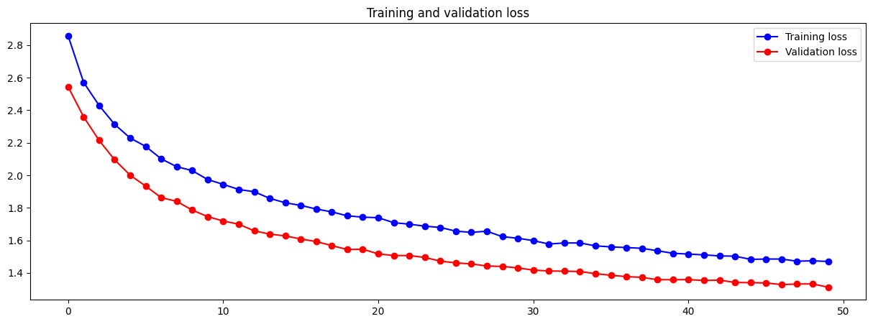

Unfreeze 4th and 5th block:

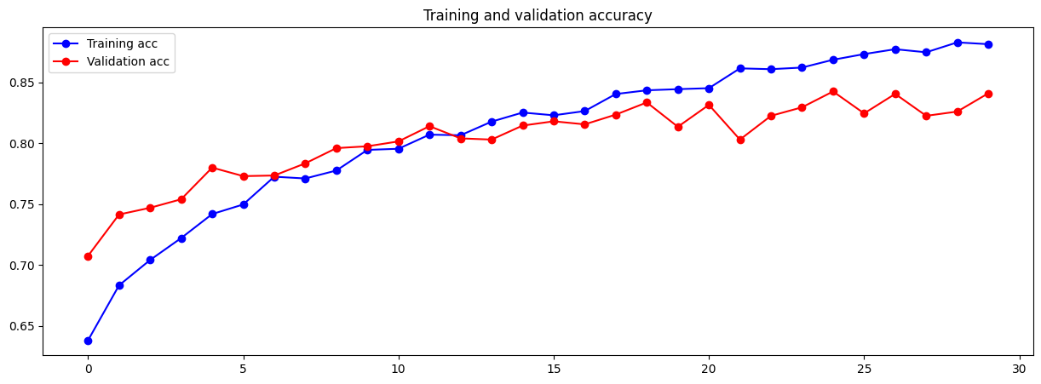

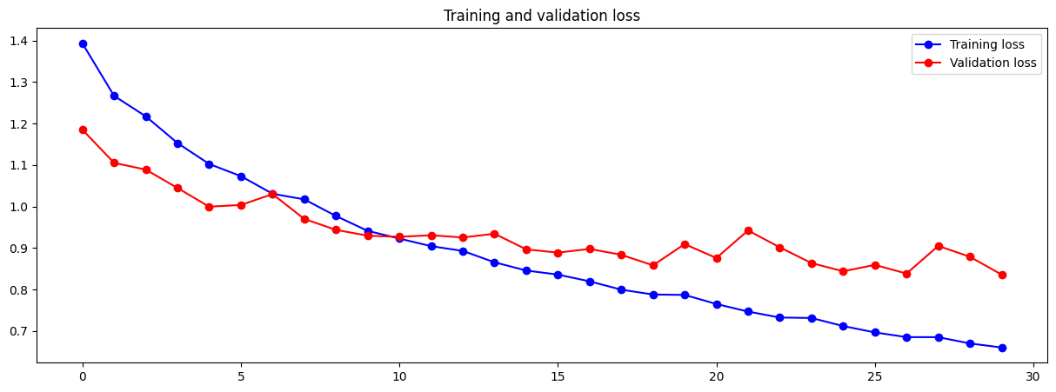

Though convergence takes place at a slower rate, overfitting has been mitigated by simply lowering the learning rate by half. Moreover, the model is better generalized.

## Pre-trained 8 - Fine Tuning (unfreeze 3rd block)

*Classifier chart will not be shown here, they are all similar to one another.

|  |
| --- |
| Architecture |
| Frozen |
| Frozen |
| Unfrozen |
| Unfrozen |
| Unfrozen |
| Dense 256, ReLU, L2 0.001 + Dropout 0.5 |
| Output 10, Softmax |

|  |
| --- |
| Other Hyperparameters |
| Optimizer: Adam |
| Learning Rate: 0.5*1e-5 / 0.000005 |
| Batch size: 32 |
| Epoch: 30 |

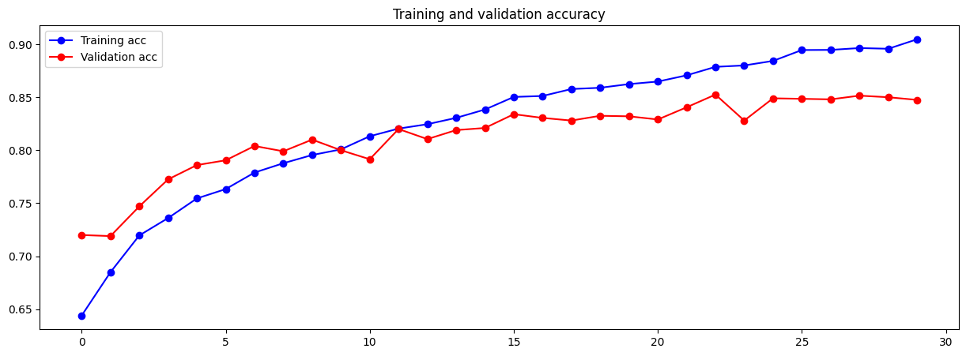

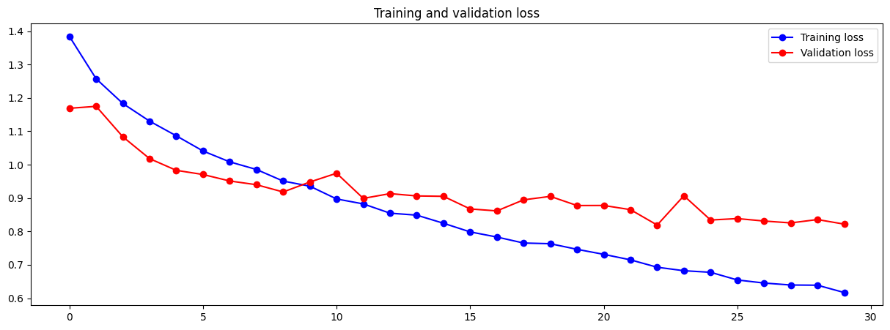

Validation accuracy is now better stabilized at around 85%. However, there is still a potential of overfitting if trained further.

## Pre-trained 9 – Tuning Learning Rate

Since unfreezing the third block makes the model more complex by introducing weights within that block, and lowering learning rate has shown better generalization and mitigation of overfitting in pre-trained 7, the learning rate was once again lowered.

* Classifier chart will not be shown here, they are all similar to one another.

|  |
| --- |
| Frozen |
| Frozen |
| Unfrozen |
| Unfrozen |
| Unfrozen |
| Dense 256, ReLU, L2 0.001 + Dropout 0.5 |
| Output 10, Softmax |

|  |
| --- |
| Other Hyperparameters |
| Optimizer: Adam |
| Learning Rate: 0.3*1e-5 / 0.000003 |
| Batch size: 32 |
| Epoch: 30 |

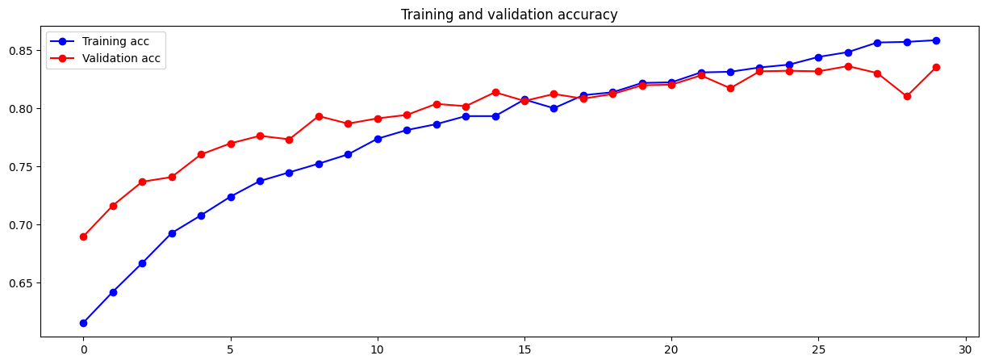

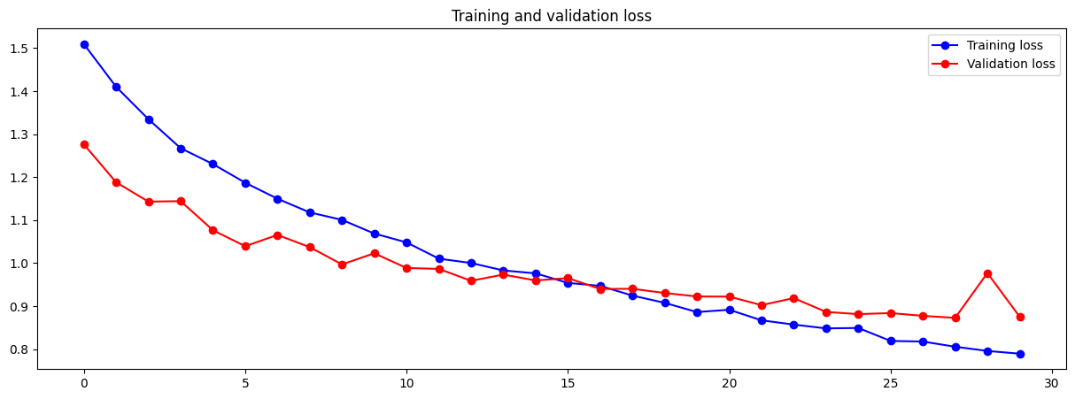

Our expectation was met, divergence of training and validation loss has been mitigated, hence preventing overfitting from occurring at epoch 30, there is also a better generalization for training and validation accuracy, with now both hovering at around 85%.

## Pre-trained 10 – Training for more epoch

When the third block was unfrozen and learning rate was decreased, the models has been generalized and no sign of overfitting is seen. However, there is still indication that there is space for accuracy improvement shown in both occurrences. Thus, the fine-tuning portion of the model has been trained for 100 epochs.

* Classifier chart will not be shown here, they are all similar to one another.

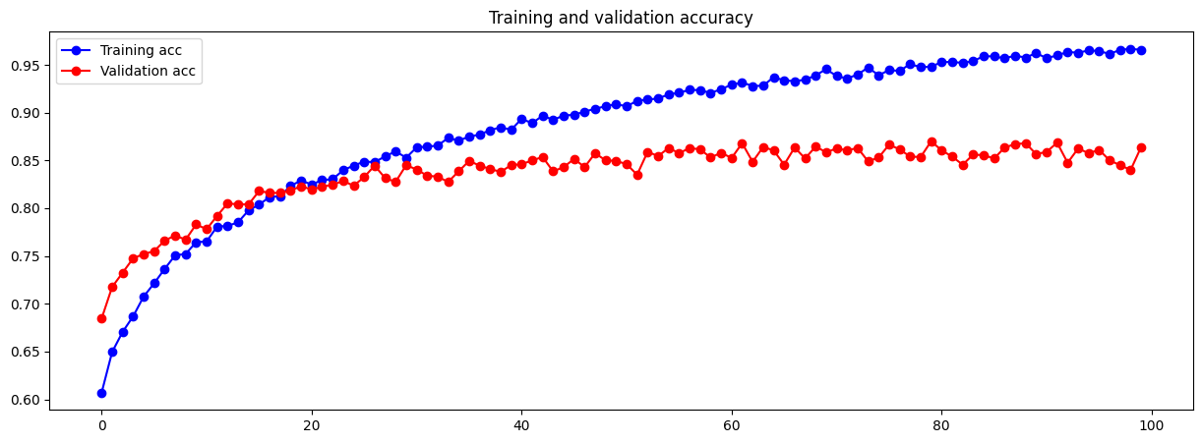

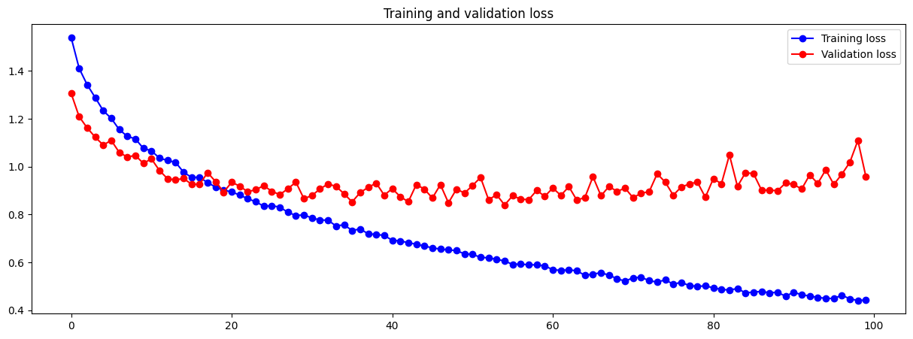

The model now comfortably sits at a validation accuracy of 84% ever since epoch 30 and above, with its highest being 87%. The train accuracy in this model has also reached a new high of 96%.

With high confidence of validation accuracy being 84%-85%, I am satisfied with this pre-trained model.

# Evaluate models using Test Images

A for loop will be used to loop through all the h5 files saved and each file will be loaded and evaluated with the test images to obtain test accuracy and test loss with each model. After each iteration, the performance metric will be saved in a numpy array which will be converted to a pandas dataframe afterwards.

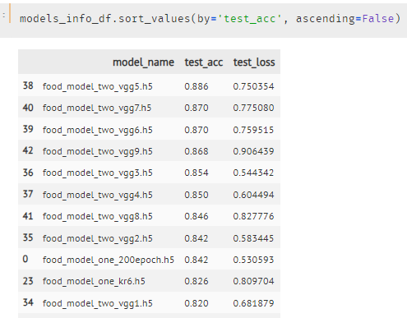

After sorting the test_acc from highest to lowest, we can see that the top 8 models are all from models built using pre-trained, concluding models built using pre-trained are of higher quality.

Next, we will subset the dataframe with only models built using pre-trained and display two tables, one is sorted by highest to lowest test_acc while the other is test_loss sorted by lowest to highest. This will assist us in choosing which is the best model among all the models built.

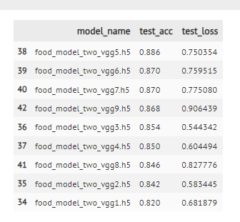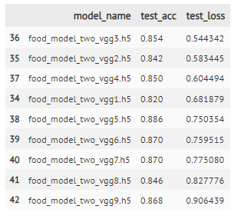

[right is test_acc highest to lowest, left is test_loss lowest to highest]

The decision on which is the best model will be chosen based on a process of elimination. We will first look at the first row of the right table. Third vgg model and find the corresponding model on the left table. If the accuracy is considered low among others and there are better models in the right table in terms of test_acc, it will cancelled out.

Repeating the above process of elimination, the final model I picked was “food_model_two_vgg5”, with testing accuracy of 88.6%.

# Use the Best Model to perform classification

Using the best model saved, we will now use it to predict the food type of images found on the internet. One image of each food type assigned to me was downloaded off the net. Reference links are commented out in the Jupyter Notebook. Since the best model selected is one done by pretrained model, image size will be set to 224 by 224. Afterwards, we turn the image we initialize into arrays of pixel value and rescale the images by dividing each value by 255 to normalize the values to be between 0 to 1 so our loaded model can process and predict the image.

We will use the numpy array created to be fed into model.predict along with the list of food for the model to predict and assign a probability of classification to all the food types in the food list.

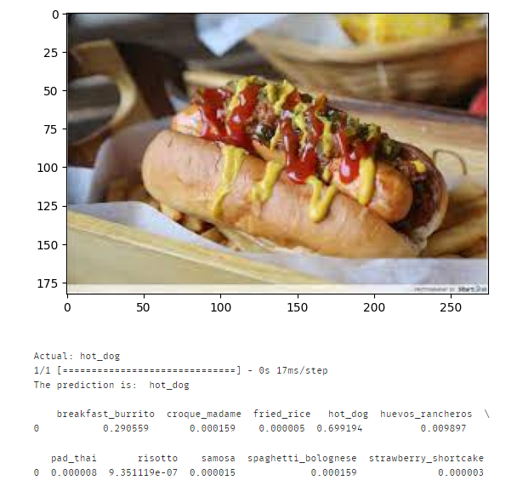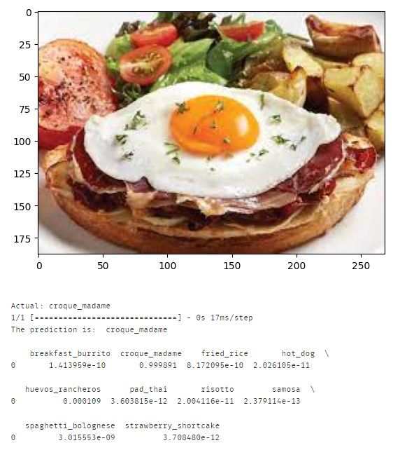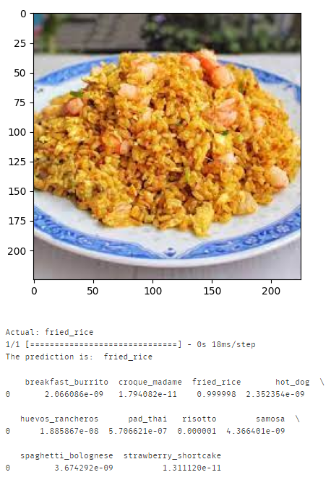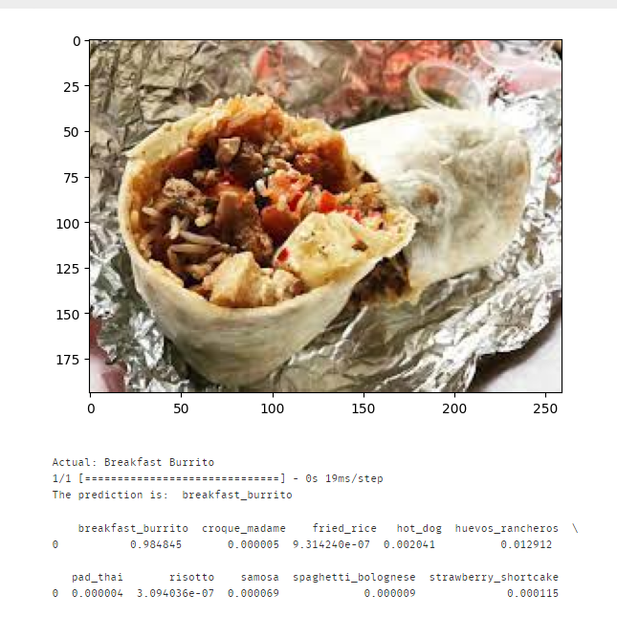

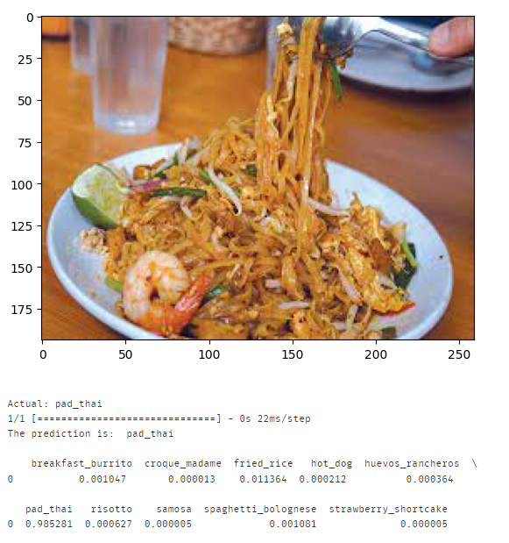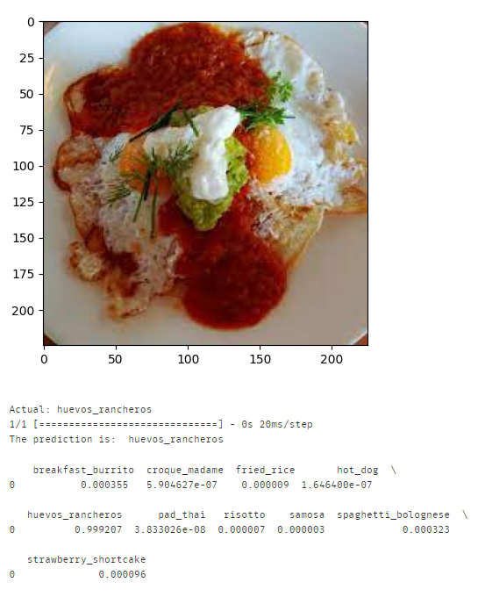

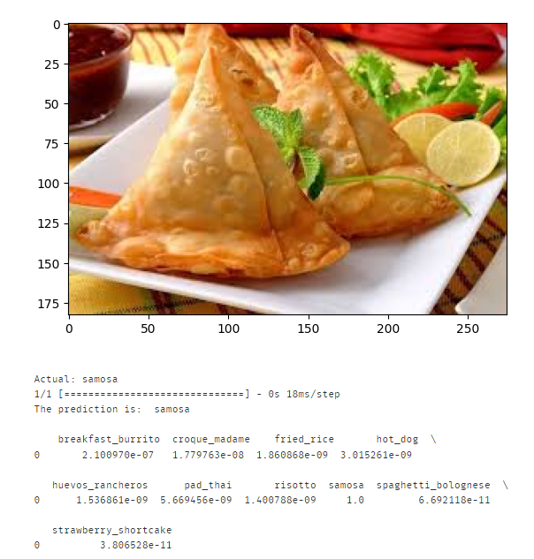

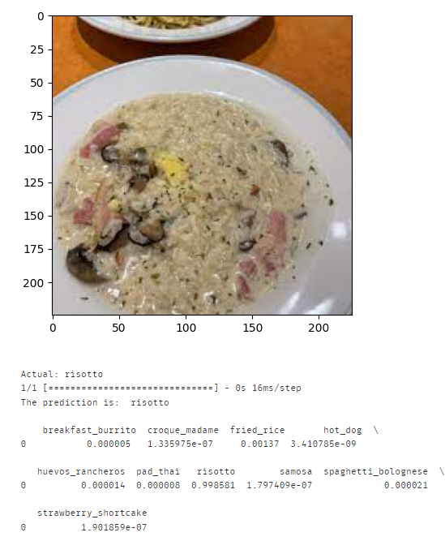

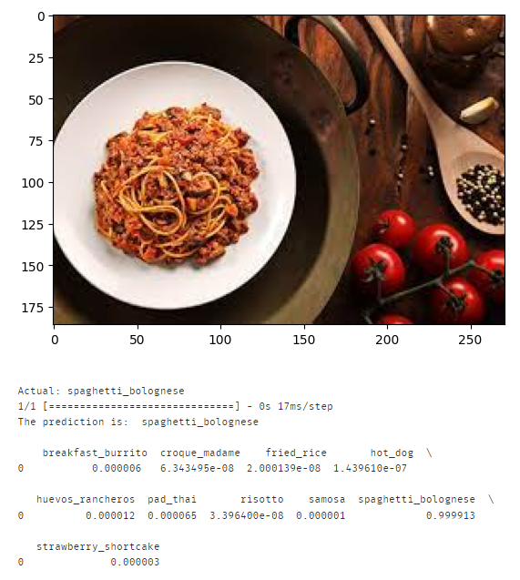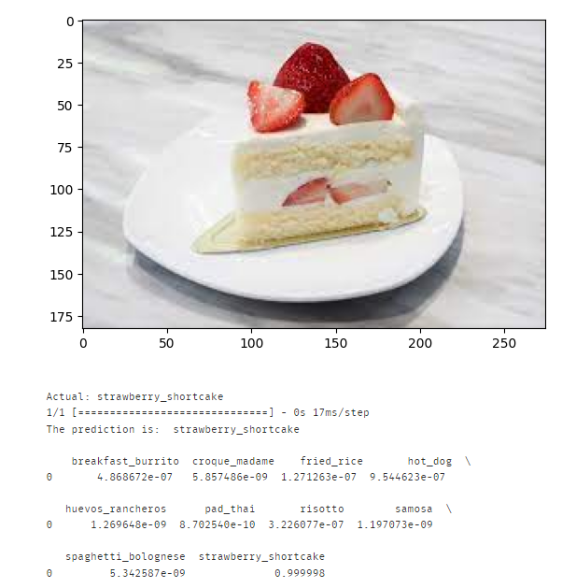

Final model predicted all the images downloaded from the internet of the 10 food types correctly, with majority having more than 98% confidence in predicting the food type correctly.

# Summary

After building 35 models from scratch and 9 models with pre-trained, the model built with pre-trained emerged the highest test accuracy of 88.6%. Using that very same model, it was able to predict all 10 food types correctly with image data installed online, acting as unseen data.

Well, it was explained in the data preprocessing and data loading part where some “noisy” data are present in the dataset. This implies that not all the data in the dataset are correctly labelled. Sure, they can be deleted from the dataset and replaced with a randomly duplicated image, but I wanted to ensure data completeness and originality from the source itself.

The one thing that could’ve been done better would be to firstly, test more combinations of hyperparameter, and secondly, research on more ways to determine whether a model is performing better than the other model. Throughout this assignment, that was only determined mainly using the shape of the accuracy and loss curves and looking out for higher validation accuracy.

The biggest challenge faced during the period of completing this assignment was, indeed, time.

# References

**NOTE:**

Some references come from a platform called Medium where a few of the articles are only available to subscribers of Medium. I do have the subscription hence am able to read the article and understand the content.

[1] Shahriyar, M. (2020, Oct 31). *Role of Image Resolution in Deep Learning*. Data Science Stack Exchange. Retrieved from <https://datascience.stackexchange.com/a/84771>

[2] Keras. (n.d.). *Keras Applications*. Keras IO. Retrieved from <https://keras.io/api/applications/>

[3] Aashish, N. (2022, Apr 5). *Baseline Models: Your Guide For Model Building*. Medium. Retrieved from <https://towardsdatascience.com/baseline-models-your-guide-for-model-building-1ec3aa244b8d#:~:text=A%20baseline%20model%20is%20essentially,a%20necessity%20for%20many%20reasons.>

[4] Philipp, W. (2020, Dec 17). *Which Optimizer should I use for my ML Project?* Lightly. Retrieved from <https://www.lightly.ai/post/which-optimizer-should-i-use-for-my-machine-learning-project#:~:text=One%20key%20difference%20between%20Adam,with%20little%20hyper%2Dparameter%20tuning.>

[5] Lili, J. (2020, Jun 7). *A Visual Explanation of Gradient Descent Methods (Momentum, AdaGrad, RMSProp, Adam)*. Medium. Retrieved from <https://medium.com/towards-data-science/a-visual-explanation-of-gradient-descent-methods-momentum-adagrad-rmsprop-adam-f898b102325c>

[6] Enes, Z. (2023, Mar 16). *Relation Between Learning Rate and Batch Size*. Baeldung. Retrieved from <https://www.baeldung.com/cs/learning-rate-batch-size#:~:text=The%20batch%20size%20affects%20some,and%20a%20good%20initial%20choice.>

[7] Deep, P. (Jul 20). *Image Data Augmentation using KERAS*. Medium. Retrieved from <https://deeppatel23.medium.com/image-data-augmentation-using-keras-a1ccc595ff88>

[8] Jeremy, Z. (2020, Nov 17). *Regularization & Dropout in Deep Learning*. Medium. Retrieved from <https://medium.com/towards-data-science/regularization-dropout-in-deep-learning-5198c2bf6107>

[9] Anthony, K. (2023, Dec 4). *Batch Normalization in Neural Network Simply Explained*. Medium. Retrieved from <https://kwokanthony.medium.com/batch-normalization-in-neural-network-simply-explained-115fe281f4cd>

[10] Rukshan, P. (2022, Sep 27). *Determining the Right Batch Size for a Neural Network to Get Better and Faster Results*. Medium. Retrieved from <https://medium.com/data-science-365/determining-the-right-batch-size-for-a-neural-network-to-get-better-and-faster-results-7a8662830f15#:~:text=It%20is%20a%20good%20practice,requires%20fewer%20epochs%20to%20converge.>

[11] B. Chen. (2021, Jan 4). *7 popular activation functions you should know in Deep Learning and how to use them with Keras and TensorFlow 2*. Medium. Retrieved from <https://towardsdatascience.com/7-popular-activation-functions-you-should-know-in-deep-learning-and-how-to-use-them-with-keras-and-27b4d838dfe6>

[12] Random. N. (2017, Oct 23). *Swish Activation Function by Google*. Medium. Retrieved from <https://medium.com/@neuralnets/swish-activation-function-by-google-53e1ea86f820>

[13] Swarnima. P. (2020, Jun 23). *How to choose the size of the convolution filter or Kernel size for CNN?* Medium. Retrieved from <https://medium.com/analytics-vidhya/how-to-choose-the-size-of-the-convolution-filter-or-kernel-size-for-cnn-86a55a1e2d15>

[14] Rukshan, P. (2022, Jul 6). *How to Apply L1 and L2 Regularization Techniques to Keras Models*. Medium. Retrieved from <https://medium.com/data-science-365/how-to-apply-l1-and-l2-regularization-techniques-to-keras-models-da6249d8a469>

[15] Great, L. (2021, Sep 23). *Everything you need to know about VGG16.* Medium. Retrieved from <https://medium.com/@mygreatlearning/everything-you-need-to-know-about-vgg16-7315defb5918>

# Appendix

Appendix A.

|  |
| --- |
| The build-up of concept explanation will be in this order:  Vanilla Gradient Descent 🡪 Momentum 🡪 AdaGrad 🡪 RMSProp 🡪 Adam  What is Vanilla Gradient Descent / Momentum? A simple way to put it is that they are both optimization algorithms used to update the weights of a neural network during the training process. The aim of these algorithms is to minimize the error or loss function associated with the network’s predictions.  Vanilla Gradient Descent:  In deep learning, gradient descent minimizes a loss function by adjusting model parameters using gradients. It works by:   1. Computing gradients to determine the steepest descent direction. 2. Adjusting parameters based on these gradients iteratively. 3. Repeating this process to gradually minimize the loss function.   In other words, it navigates a loss surface, adjusting parameters step by step, aiming for lower loss values.  Momentum:  Momentum in gradient descent is akin to a ball rolling in a frictionless bowl, accumulating momentum and moving continuously.  This concept enhances gradient descent by including past movement:   * It adds the previous step’s momentum to the current gradient calculation. * The decay rate parameter controls momentum accumulation:   + A rate of 0 equals to vanilla gradient descent.   + A rate of 1 causes oscillation; a rate around 0.8 – 0.9 is typical for smoother convergence.   Advantages of Momentum over Vanilla Gradient Descent:   1. Enhanced Speed:   Momentum moves faster due to accumulated momentum from past steps.   1. Escaping local minima:   Momentum has the potential to escape local minima since its accumulated momentum can propel it out.  Adagrad:  Adagrad uses squared gradients to adapt updates:   * Tracks squared gradients for each dimension. * Adjusts gradients based on this information. * Balances updates for features, aiding slower ones. * Escape saddle points better than vanilla gradient descent or momentum. * Efficiently navigates complex landscapes in optimization.   RMSprop:  RMSprop tackles AdaGrad’s slow learning by introducing a decay factor:   * Computes decayed sum of gradient squares. * Adjusts gradients based on this decayed information. * Prevents rapid accumulation, enabling continued effective movement. * Faster optimization compared to AdaGrad due to controlled growth of gradient squares.   Adam:  Adam combines Momentum and RMSprop to create an effective optimizer:   * Utilizes both momentum and RMSprop principles. * Calculates first moment (sum of gradient) and second moment (sum of gradient squared). * Employs decay rates for each moment, commonly set at 0.9 and 0.999 respectively. * Adjusts gradients based on these moments to achieve speed and adaptability. * The combination of Momentum’s speed and RMSprop’s gradient direction adaptability makes Adam a powerful optimizer.   Reference [5] |